# **Chapter One**

# **Introduction**

# **Cam Mechanisms**

Cam mechanisms are widely used in various forms of machinery, including

internal combustion engines to actuate poppet valves.

Various methods of controlling the gas flow through an internal combustion

engine have been used or investigated. However the use of cams to provide positive cam acceleration usually in conjunction with a spring to provide the force for negative acceleration has remained the most widespread method.

The valve motion needs to be as smooth as possible to ensure stable behaviour of the mechanism at higher speeds where inertia loads will be higher and may result in significant elastic deformations of the components. Failures occur due to poor lubrication or valve spring failure.

# **The Cam Lift Curve**

The first matter for consideration by the designer is the cam lift curve. The usual way to design a cam lift curve is to start with the acceleration diagram.

The curve consists of a series of piecewise continuous sections, whose parameters can be specified by the designer. The primary design curve is acceleration, and the velocity and displacement curves are obtained by integration. The problem then consists of two simultaneous equations in two unknowns. The velocity must be *zero on the nose* and *the maximum lift can be specified by the designer*. The method used here considers half the acceleration curve and the unknowns are the maximum and minimum values of the acceleration from base circle to nose.

The acceleration needs to vary smoothly if the valve motion is to be well

controlled.

*the cam lift curve is designed in two halves. The closing side is also designed from the base circle to the nose, and the result is then mirrored. This design method requires that the acceleration is such that its derivative [Jerk] on the nose is zero. The magnitude of the acceleration and the lift on the nose must also be the same for the opening and closing sections. To achieve smoother acceleration curve, and a stable dynamic performance of the mechanism, we can start designing the can lift from the jerk diagram and be integrated to reach the cam lift curve.*

The Jerk is generally accepted as being related to valve spring surge.

# **Chapter Two**

# **Cam Design Methods**

# The development of programming software with a graphical user interface has transformed the cam design process. This has meant that more complex methods of synthesizing the valve motion can be used to improve the stability of valve motion.

The invention of the CNC cam grinding machine has resulted in more accurate cam shape manufacture.

There are different methods to design a cam. The cam function must be continuous through the first and second derivatives of displacement across the entire duration. The jerk function must be finite across the entire duration. The functions that can be used are:

1. Simple Harmonic Motion (SHM).
2. Cycloidal Displacement (sinusoidal acceleration).
3. Modified Sinusoidal Acceleration.
4. Modified Trapezoidal Acceleration.
5. Polynomial Functions. *( One Of The Best Choices For Designing a Cam* *)*

# 

# **Chapter Three**

# **Cam Design**

# **3.1. Introduction**

With the use of *polynomial and zero functions*, it is been described the acceleration and jerk curves, which they are consists of a series of piecewise continuous sections. It is been designed four types of cam from a poor rough curves design to a good smoother curves design :

1. Primitive Cam.
2. Normal Cam.
3. Accurate Cam.
4. More-Accurate Cam.

In Primitive and Normal Cam, the way used to design cam lift curve is to start from the acceleration diagram.

In Accurate and More-Accurate Cam, the way used to design cam lift curve is to start from the jerk diagram.

3.2. **Primitive Cam**

The design in this type of cam starts from acceleration, which consists of a *four continuous sections* (β1, β2, β3, β4) in primitive cam figure.

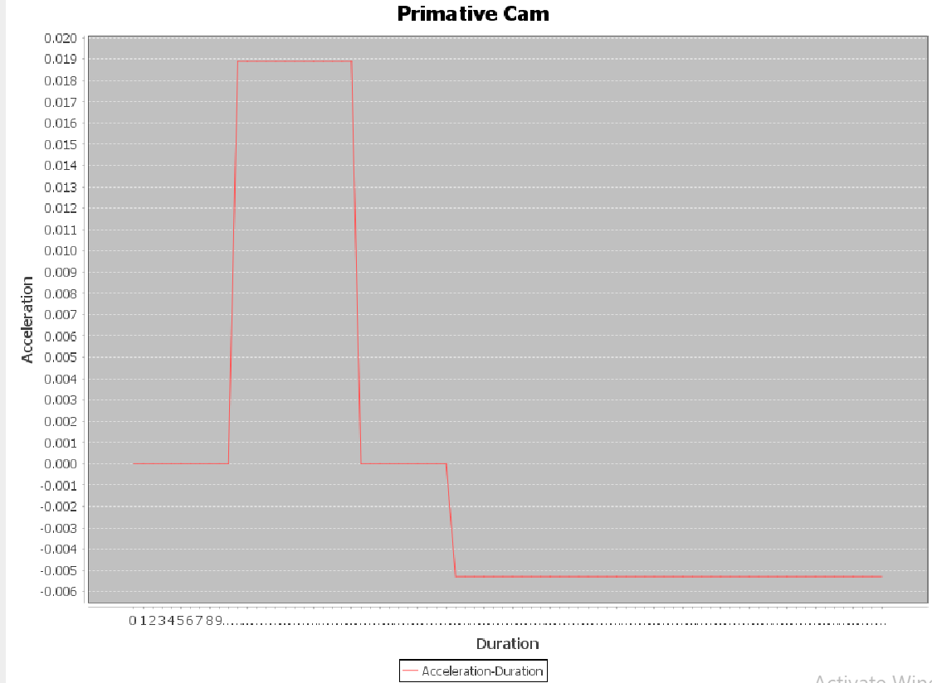

1. β1



1. β2
2. β3
3. β 4

3.3. Normal Cam

The design in this type of cam starts from acceleration diagram, which consists of a *seven continuous sections* (β1, β2, β3, β4, β5, β6, β7) in normal cam figure.

* β1 , β2 , and β3 are linear.
* β1 and β2 have the same duration, so we can have the duration step and that will be : $Z=\frac{a_{max}}{β1}$
* The duration step for β3 will be :

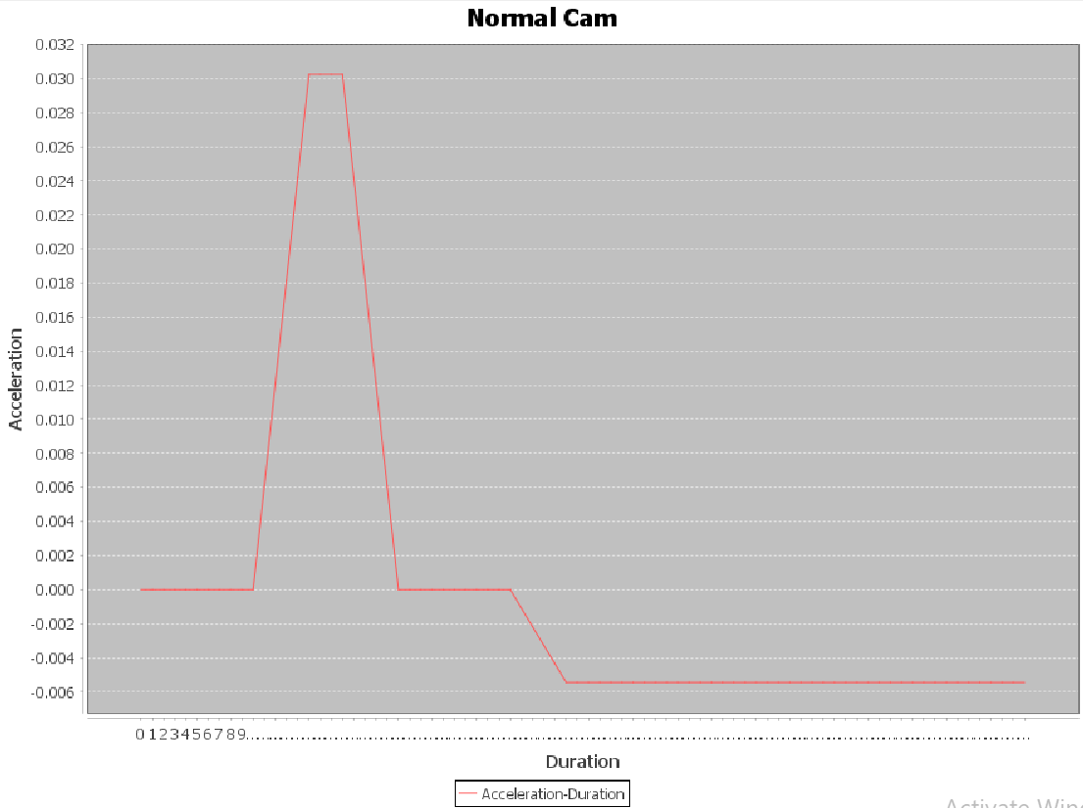

1. β2
2. β1

1. β 4
2. β 3
3. β 7
4. β 6
5. β 5
6. β 7

3.4. **Accurate Cam**

The design in this type of cam starts from jerk diagram, which consists of a *ten continuous sections* (β1, β2, β3, β4, β5, β6, β7, β8, β9, β10) in accurate cam figure.

* β2 , β3 , β5 , β6 , β8 , and β9 are linear
* β2 , β3 , β5 , and β6 have the same duration, so we can have the duration step and that will be :
* The duration step of β8 , and β9 will be :

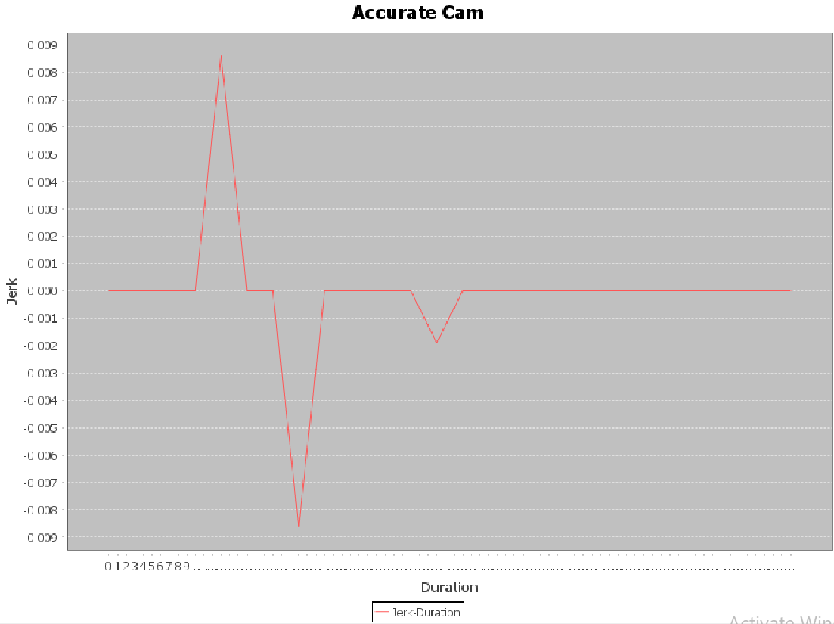

1. β 4
2. β 3
3. β 2
4. β 1
5. β 6
6. β 5
7. β 8
8. β 7
9. β 10
10. β 9

3.5. **More-Accurate Cam**

The design in this type of cam starts from jerk diagram, which consists of a *eight continuous sections* (β1, β2, β3, β4, β5, β6, β7, β8) in more-accurate cam figure.

* β2 , β3 , β4 , β5 , β6 , and β7 are linear
* β2 , β3 , β4 , and β5 have the same duration, so we can have the duration step and that will be :
* The duration step of β6 , and β7 will be :

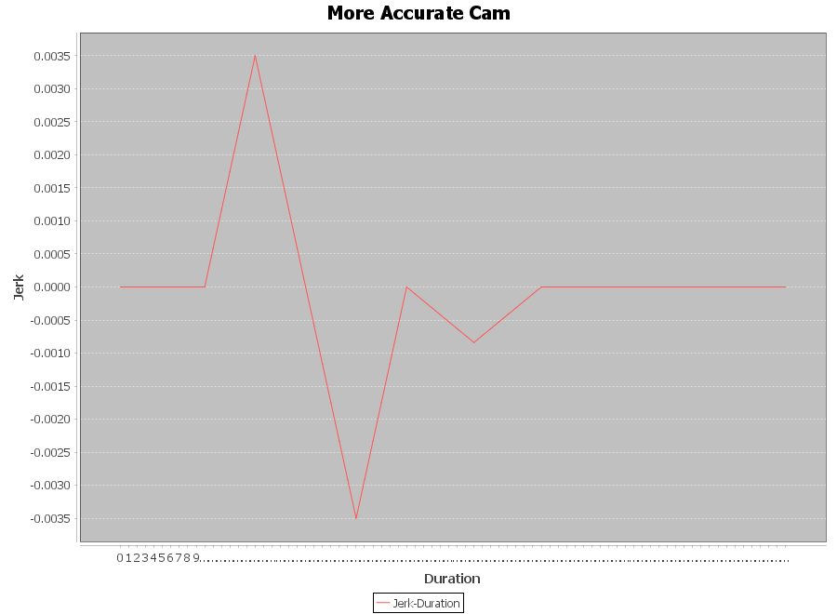

1. β 2
2. β 1
3. β 3
4. β 4
5. β 6
6. β 5
7. β 8
8. β 7

# **Chapter Four**

# **Software Program**

4.1. **Introduction**

A software application is been designed on desktop using java programming language, with the use of java swing package to create the graphical user interface.

The program can draw the opening side of the cam for half of the duration,

and full cam, opening and closing sides, for full duration. The results of the opening side of cam can be saved as an excel file with the name of the chosen cam in “cam type:” section in the interface. The saved excel file will have the results of *Displacement, Velocity, Acceleration, and Jerk* of the opening side of the chosen cam.

The program can compare the four types of cam in one figure. And can

compare the displacement, velocity, acceleration, and jerk of one type of cam in one figure.

4.2. **Interface**

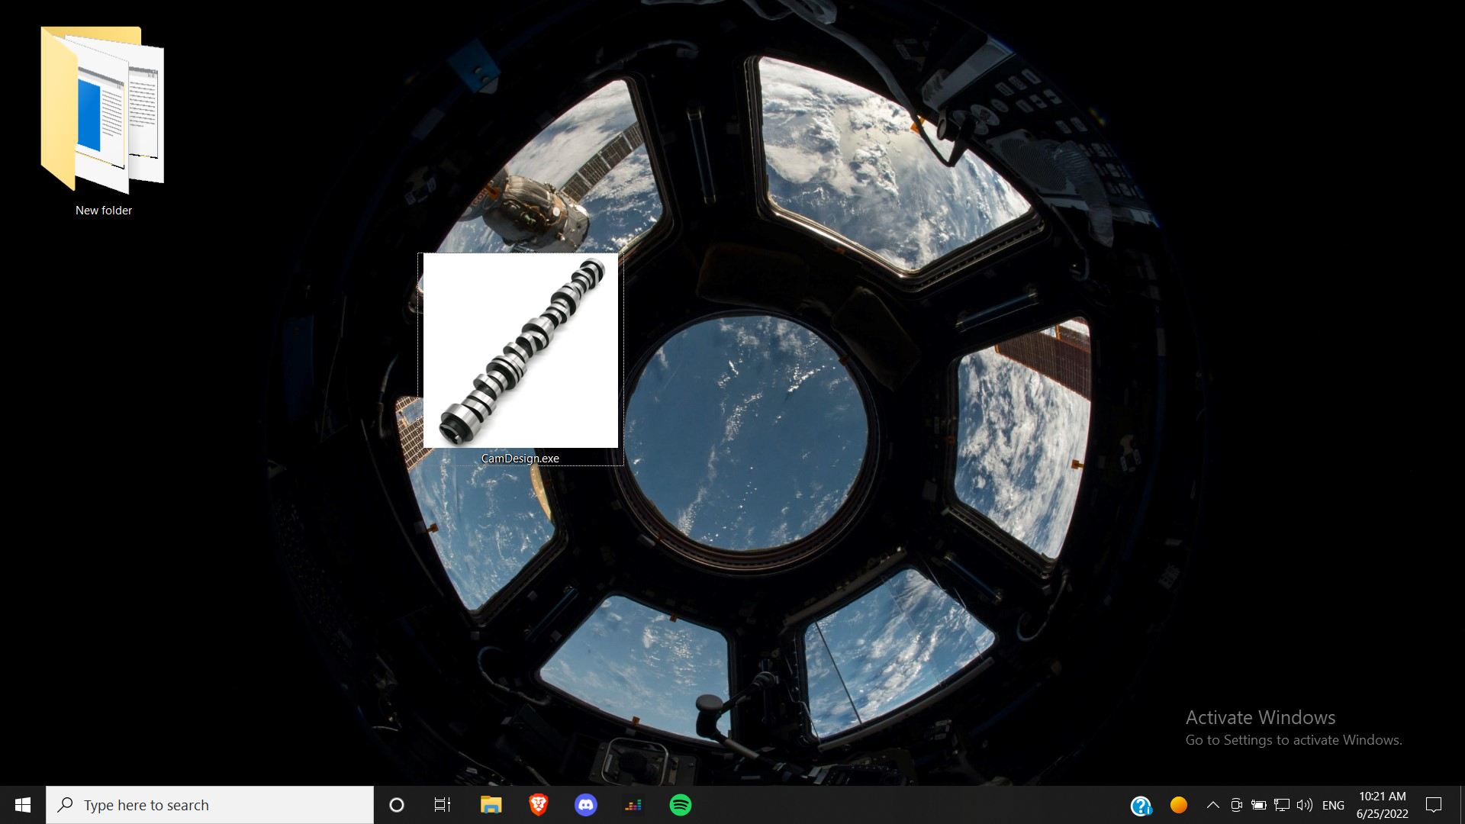

*(CamDesign ) Application Icon*



*Three Buttens :*

*- (Plot) to draw (S-V-A-J) in one figure.*

*- (Save) to save opening data of chosen duration and cam lift in excel file.*

*- (Cam Profile)*

*Enter duration and cam lift in text boxes.*

*Four buttons to draw displacement, velocity, acceleration, and jerk*

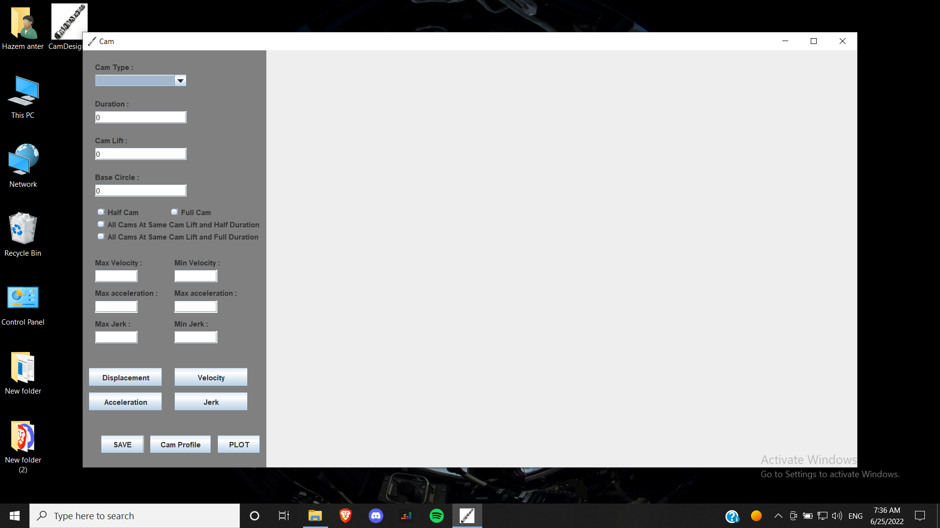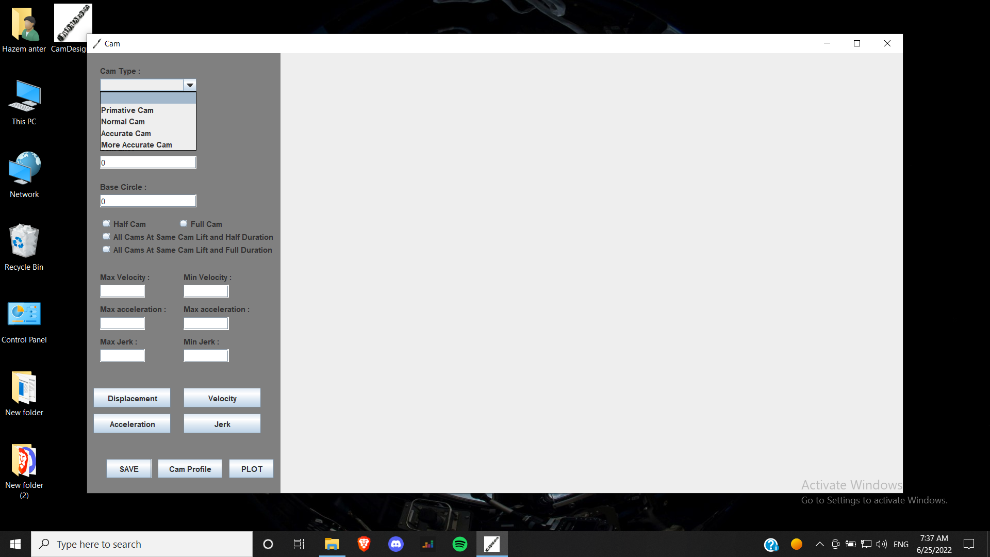

*(Cam Type) slide bar. You can select one of the available four cams.*

*You can select one of four options:*

*1- (Half Cam) to draw opening side.*

*2- (Full Cam) to draw opening & closing sides.*

*3- (All … Half Duration) to compare all types of cam.*

*4- (All … Full Duration) to compare all types of cam.*

*(S-V-A-J)* is the displacement, velocity, acceleration, & jerk

4.3. **Primitive Cam**

*Draw Displacement*

*1-Selecting the cam type (Primitive).*

*2-Enter Duration and Cam Lift.*

*3-Select Half Cam*

*4-Click on Displacement Button*

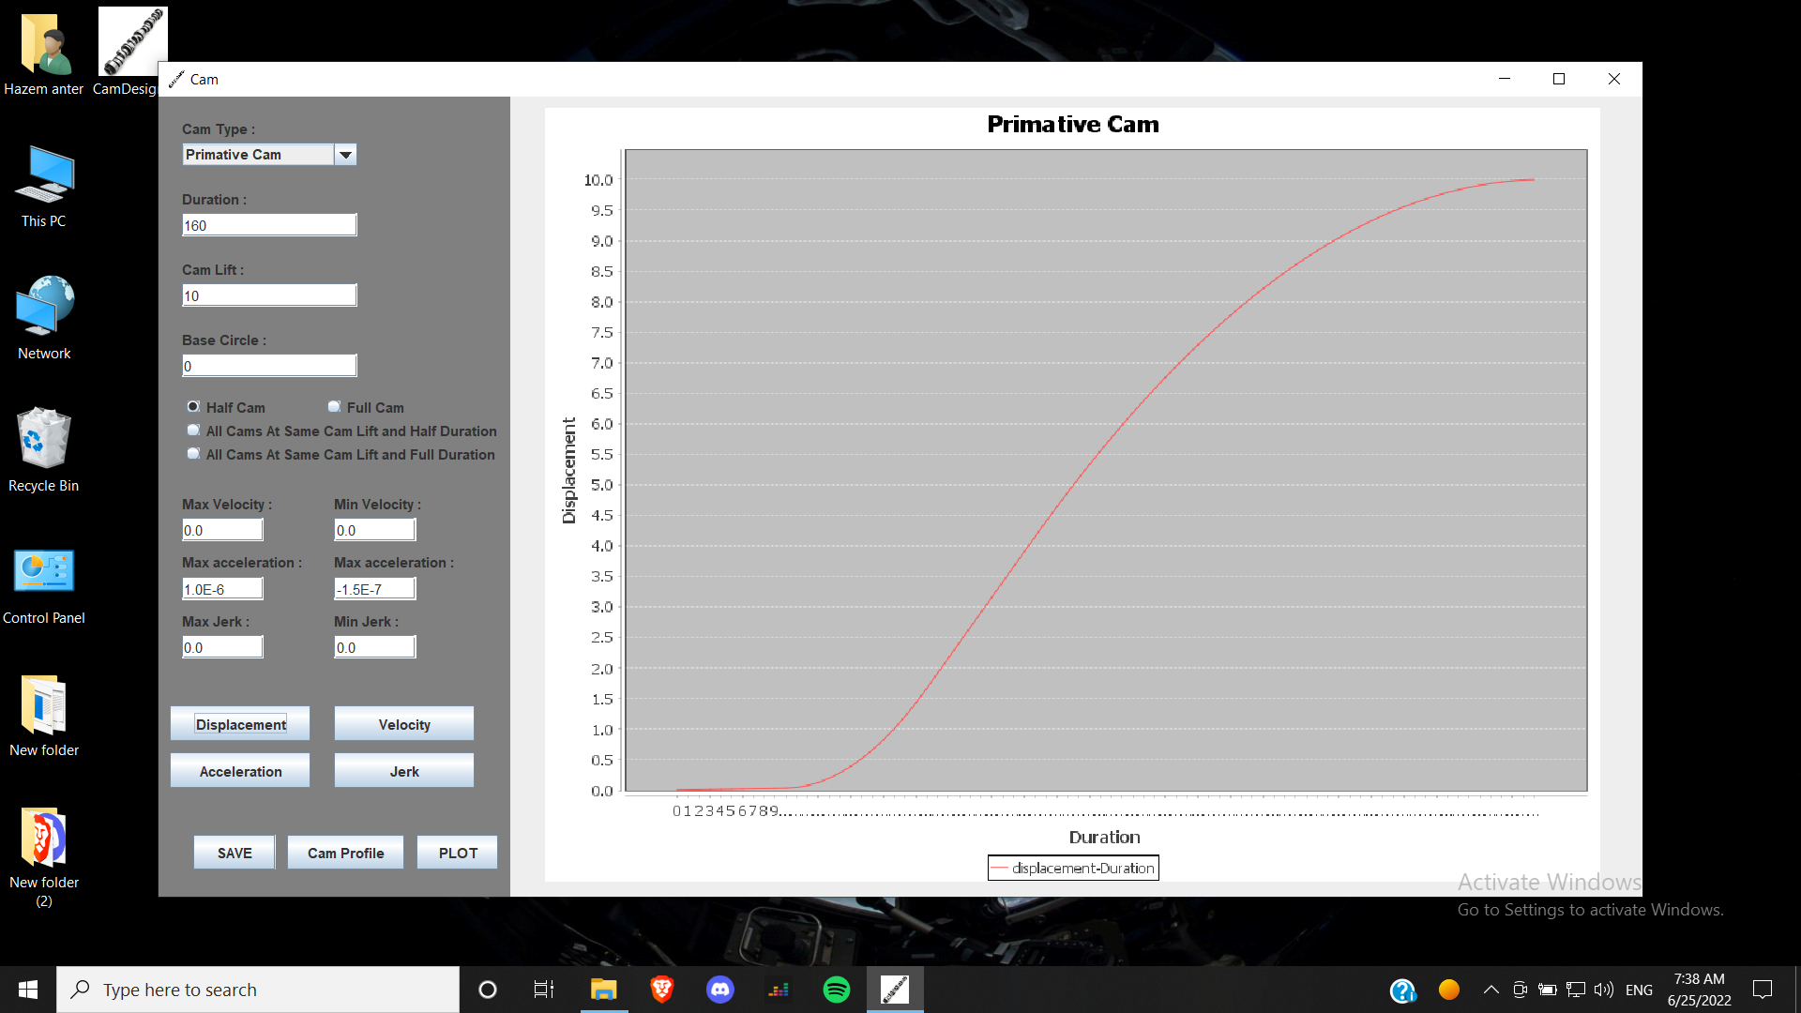

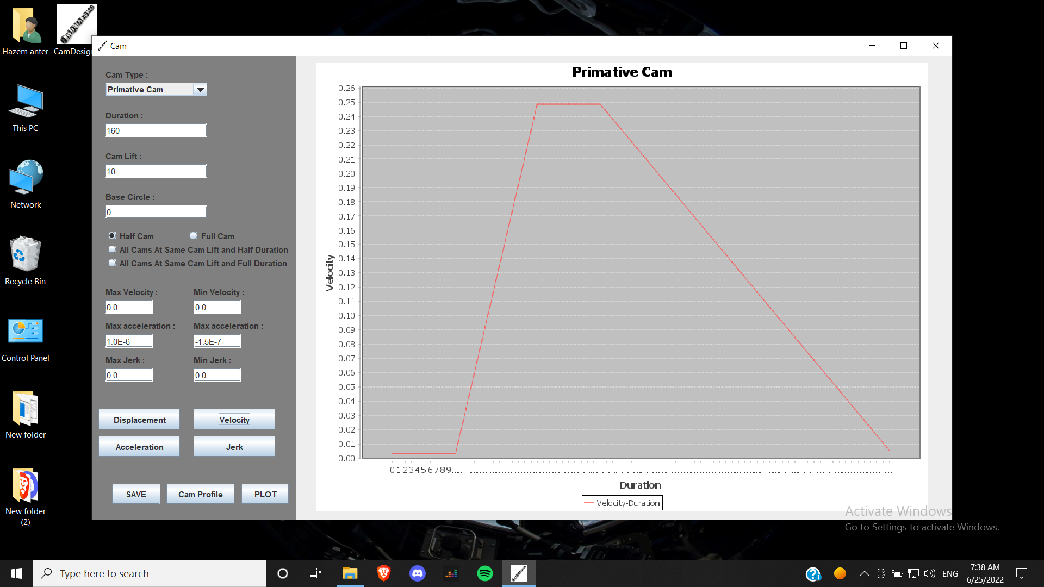

*Draw Velocity*

*The same steps as drawing displacement, but you must click on velocity Button*

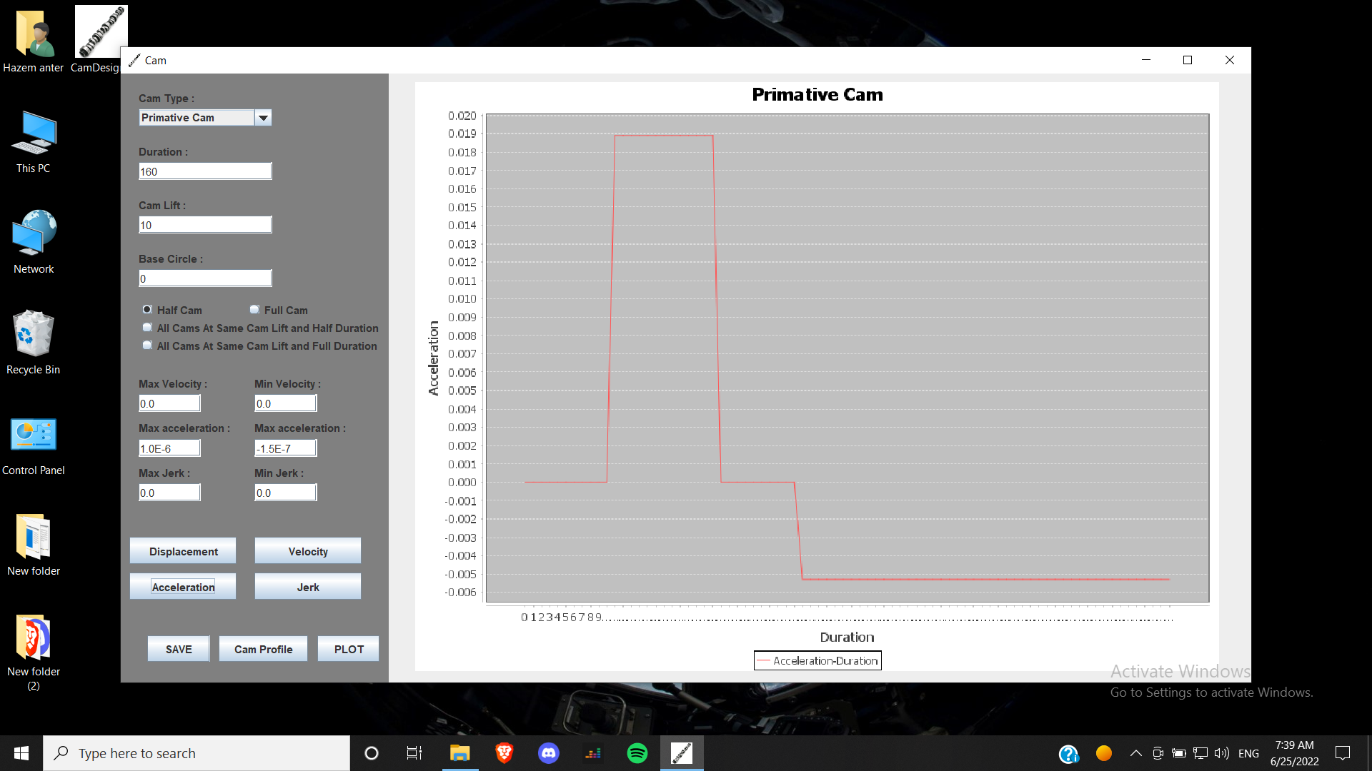

*Draw Acceleration*

*The same steps as drawing displacement, but you must click on acceleration Button.*

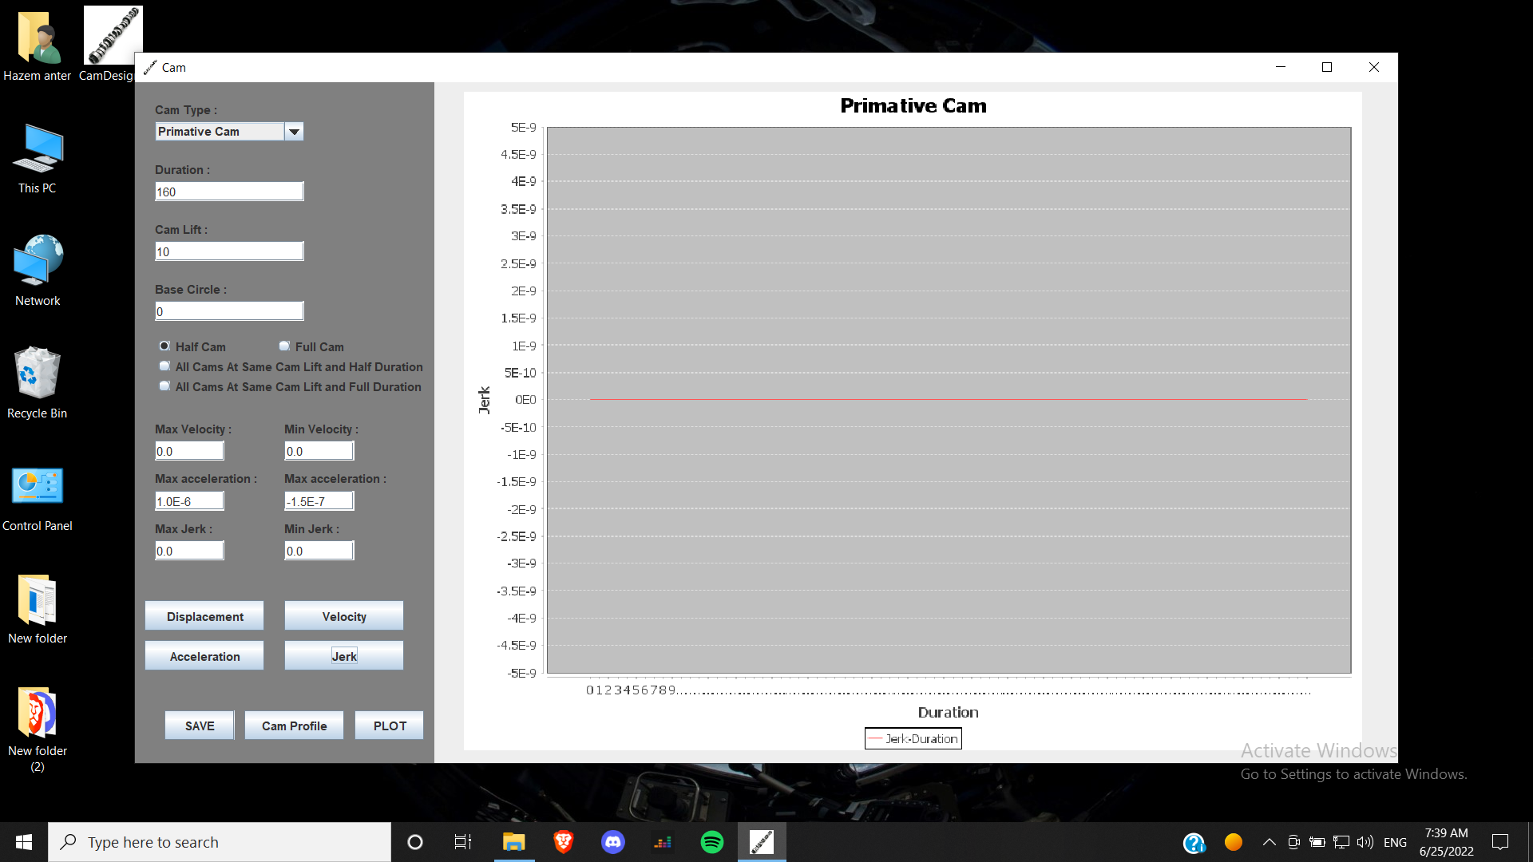

*Draw Jerk*

*The same steps as drawing displacement, but you must click on jerk Button.*

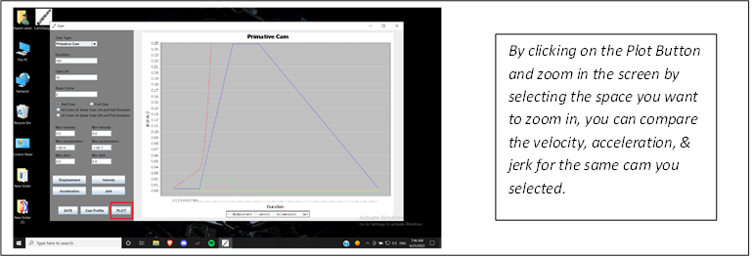

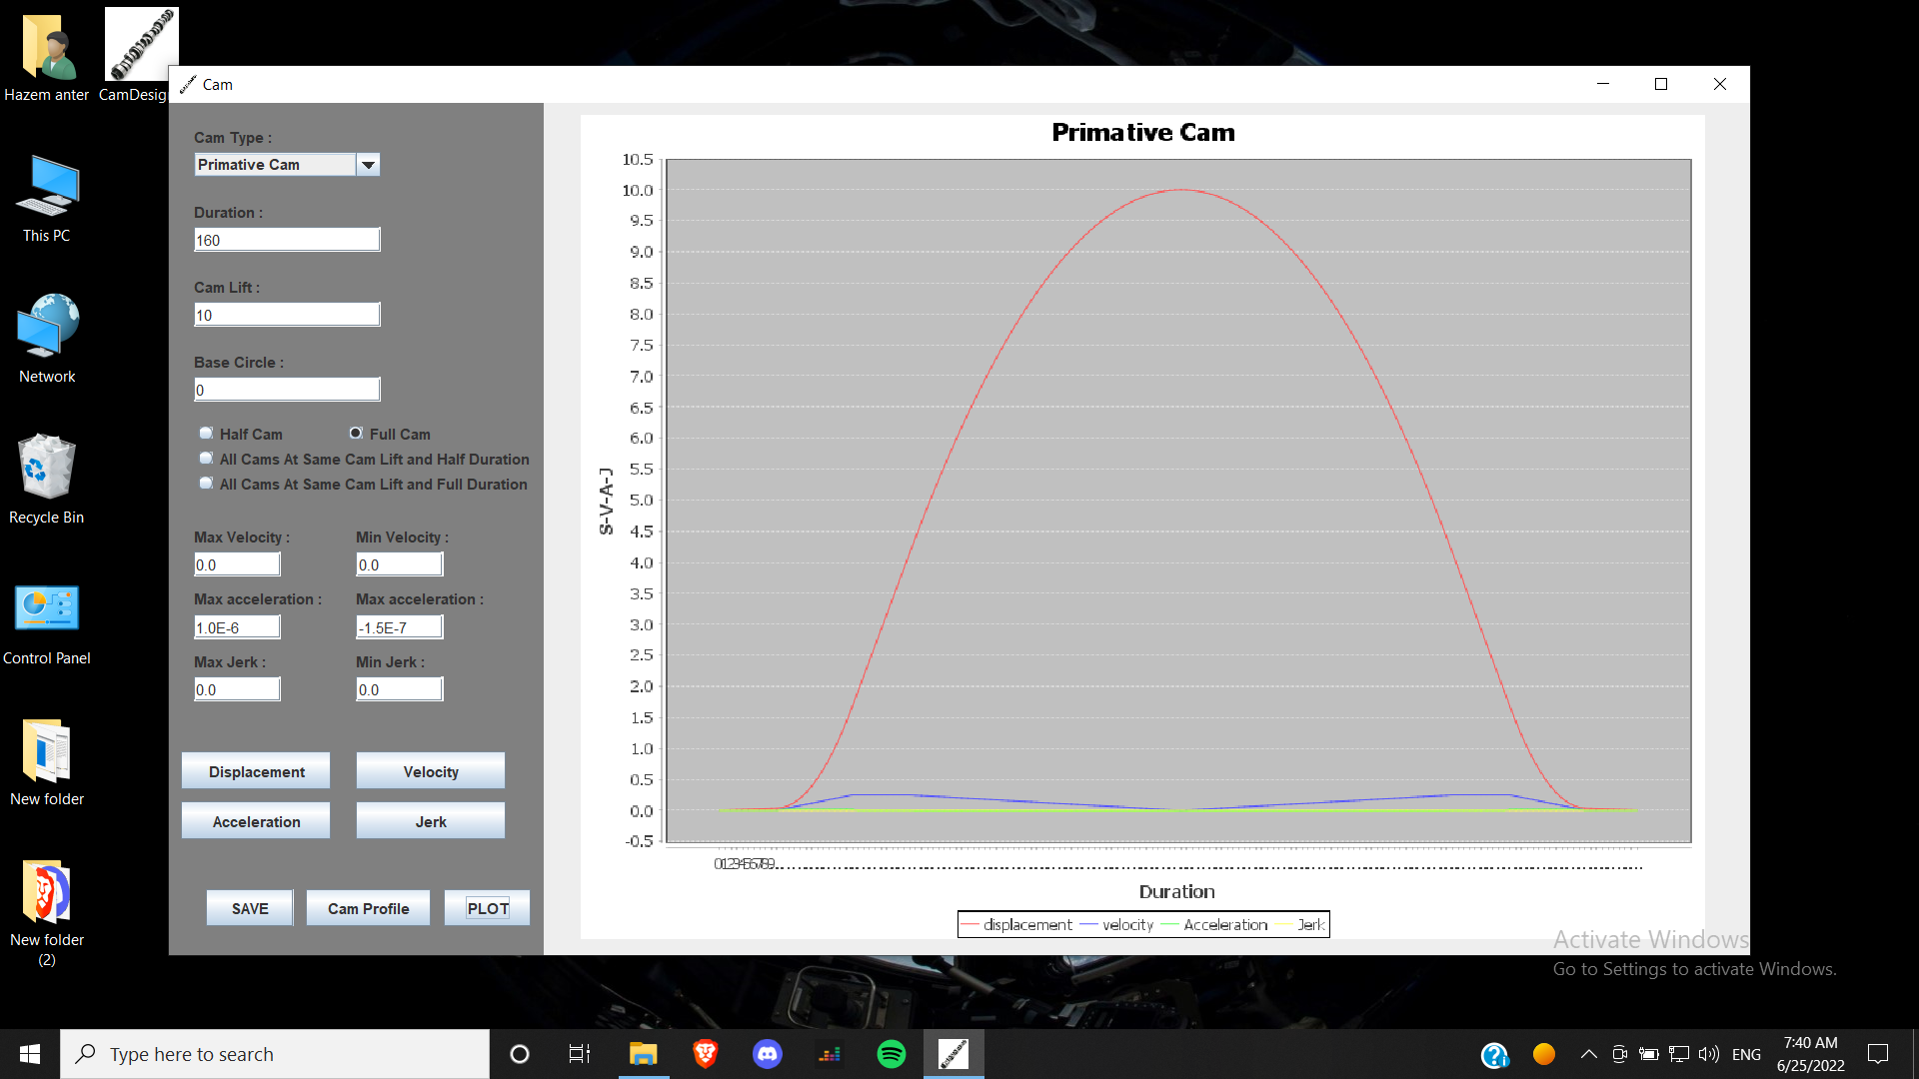

*Draw Full Cam*

*By selecting (full cam) and press plot button*

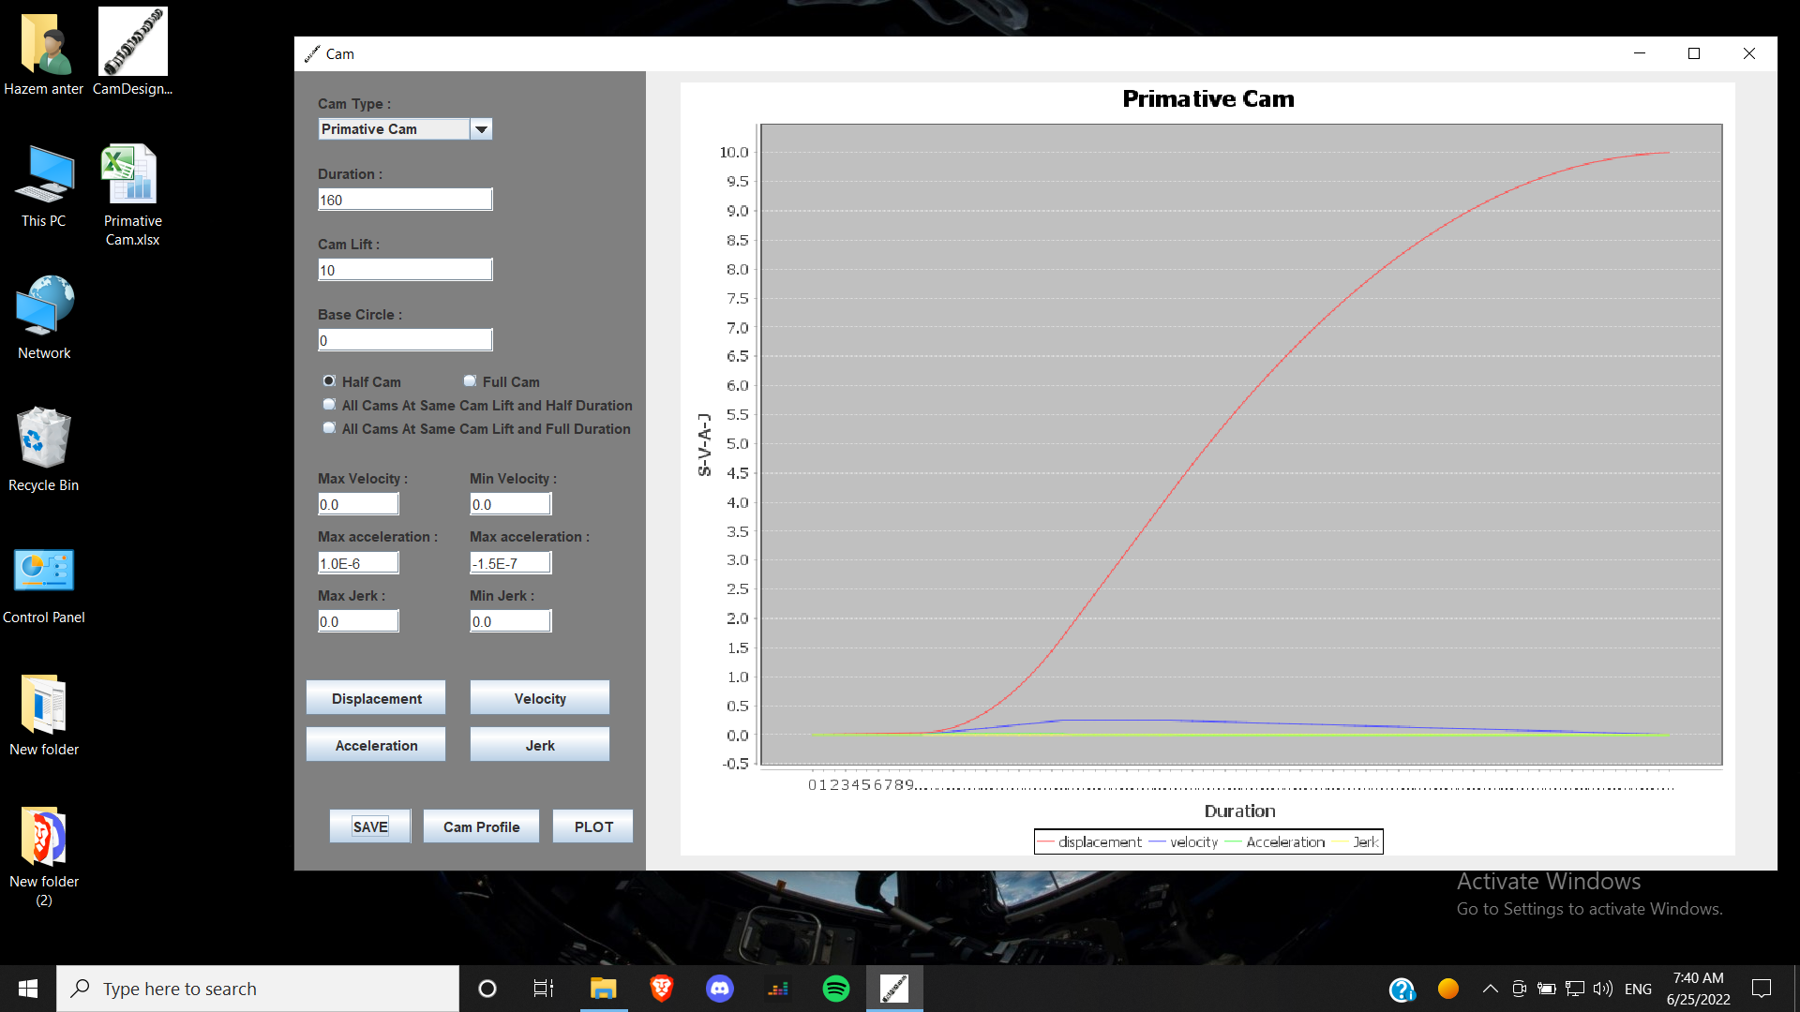

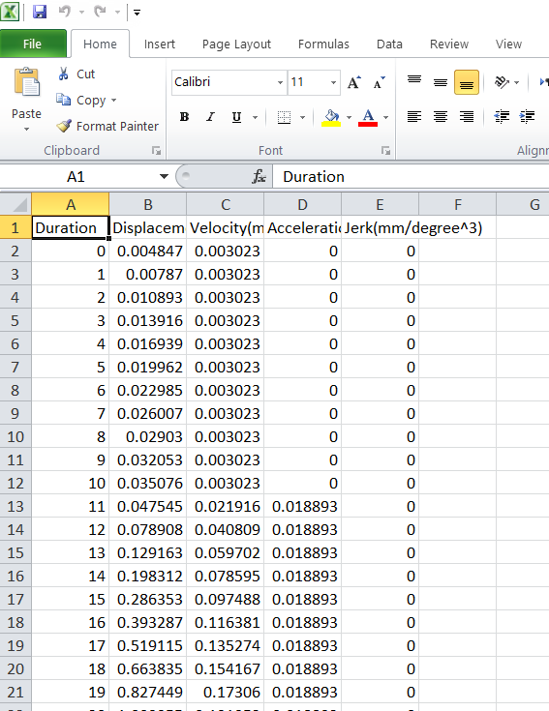

* It will be the same steps for the other cams.

4.4. **Normal Cam**

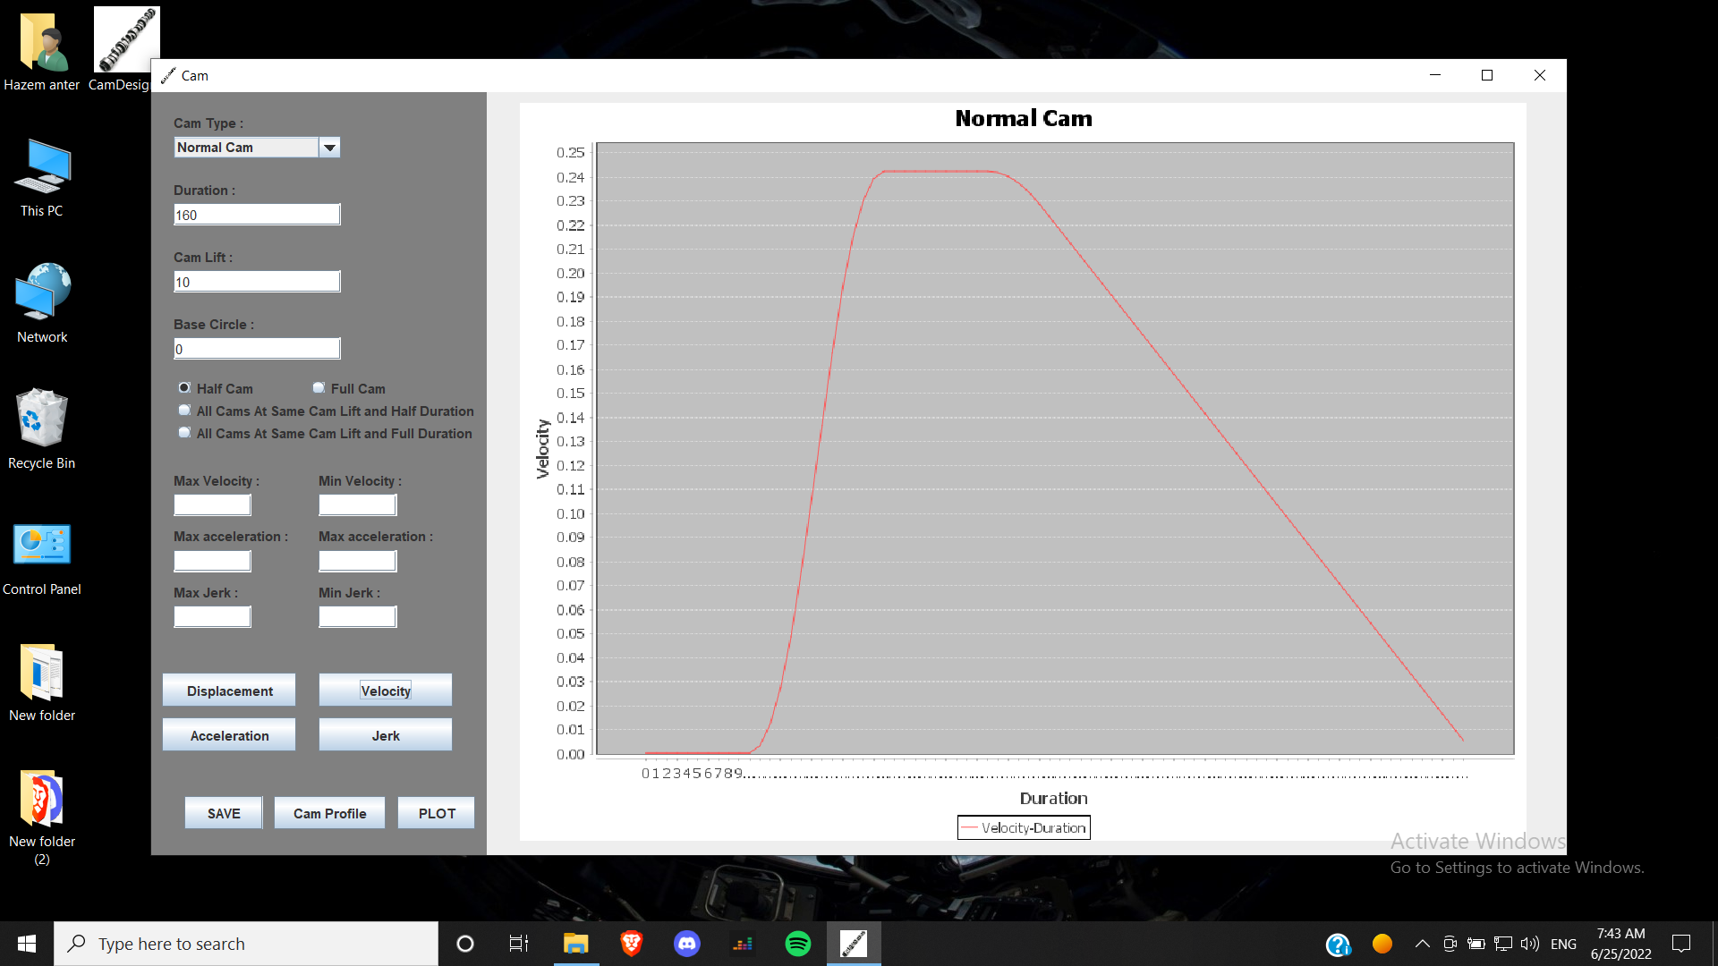

Velocity

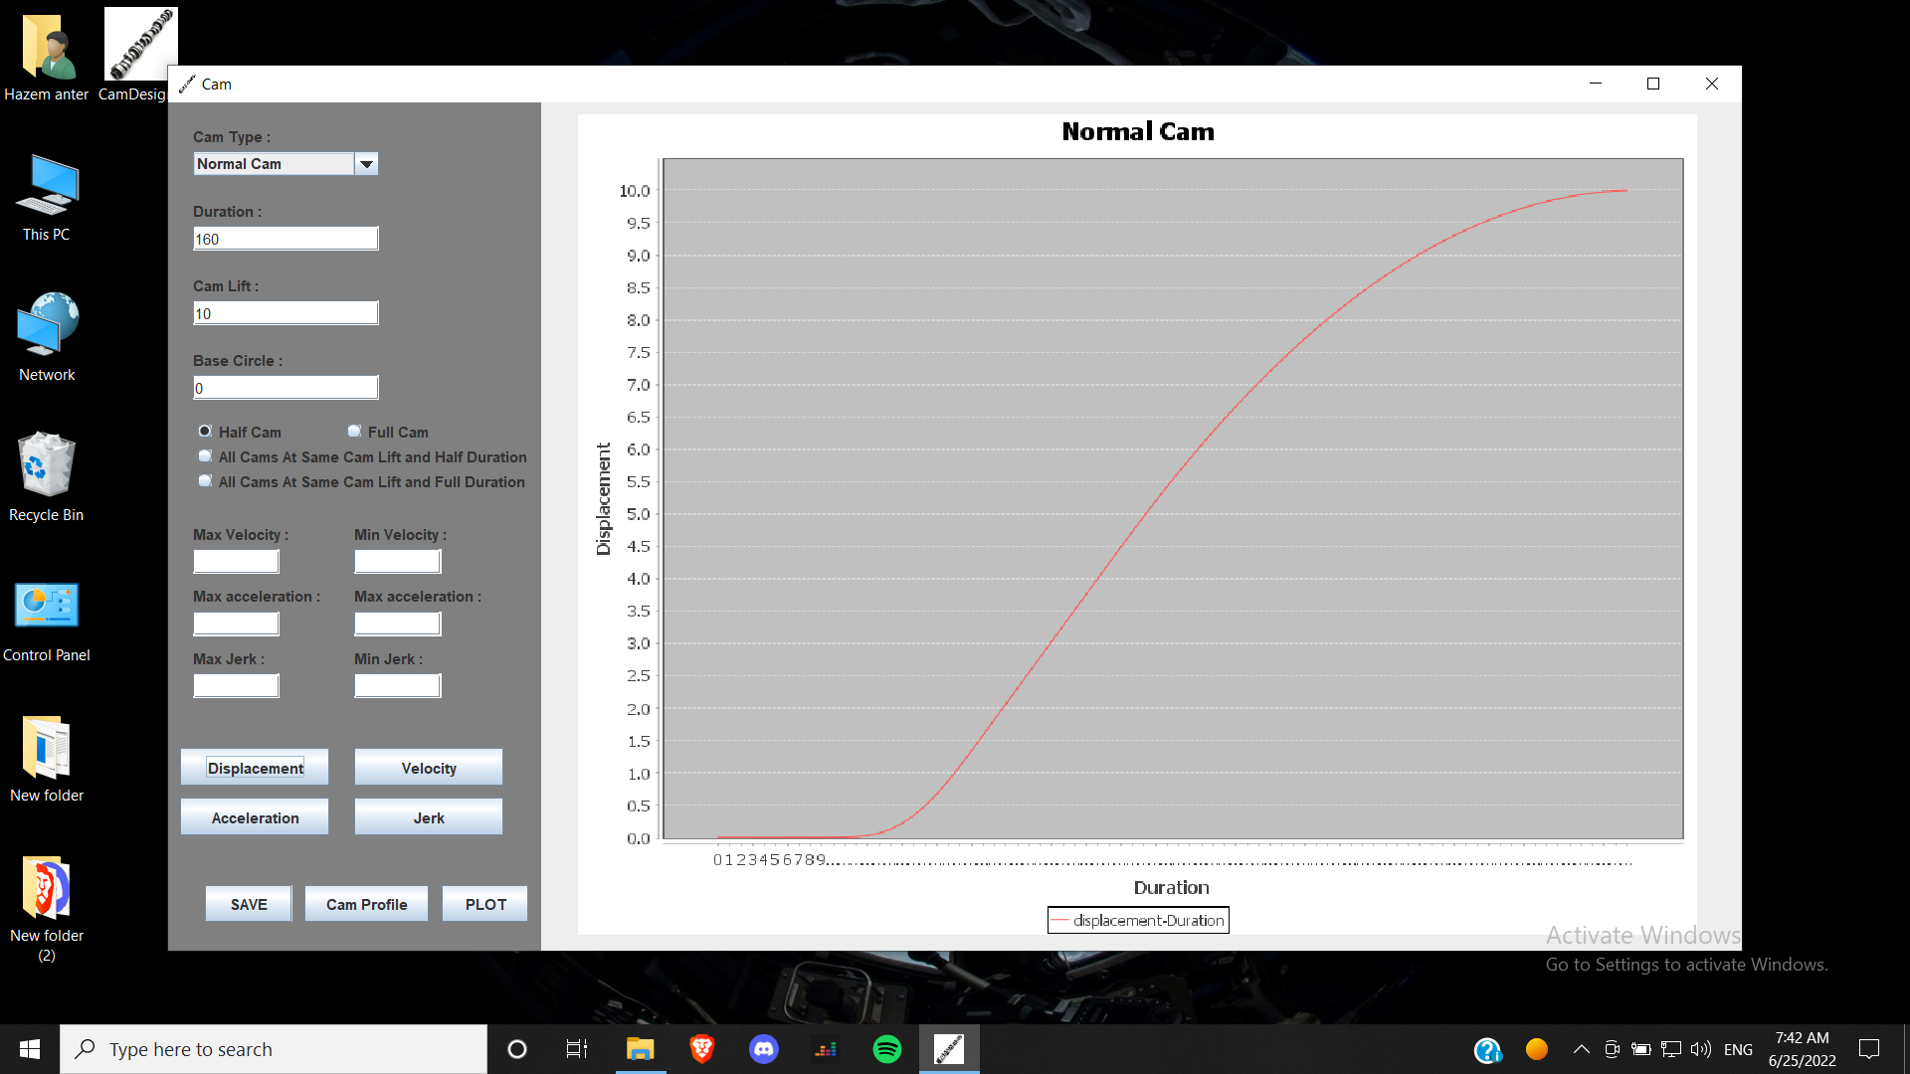

Displacement

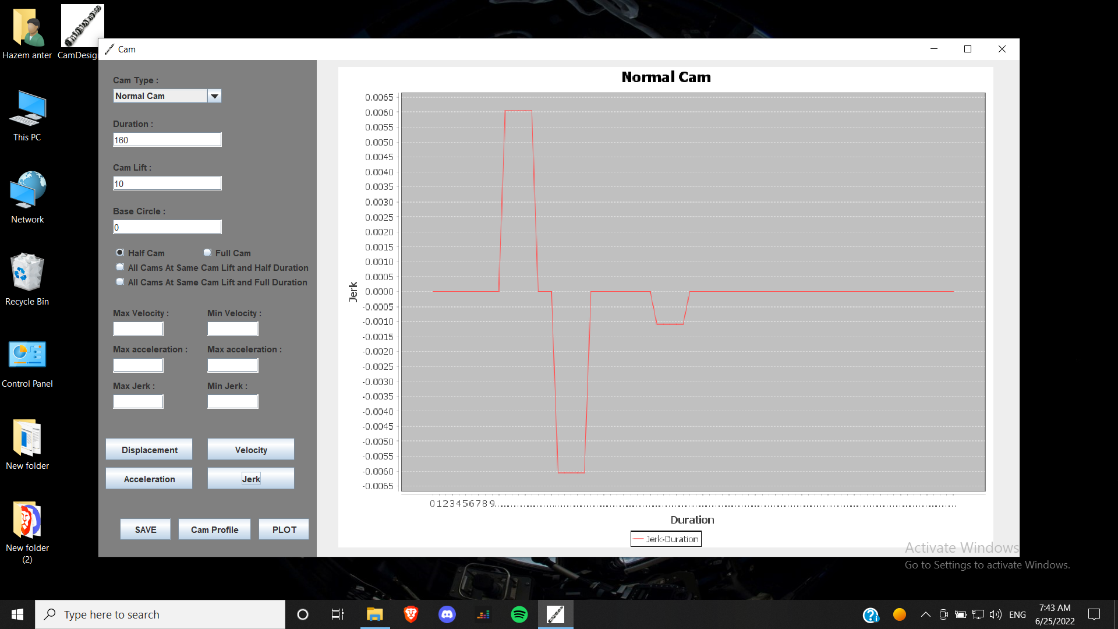

Jerk

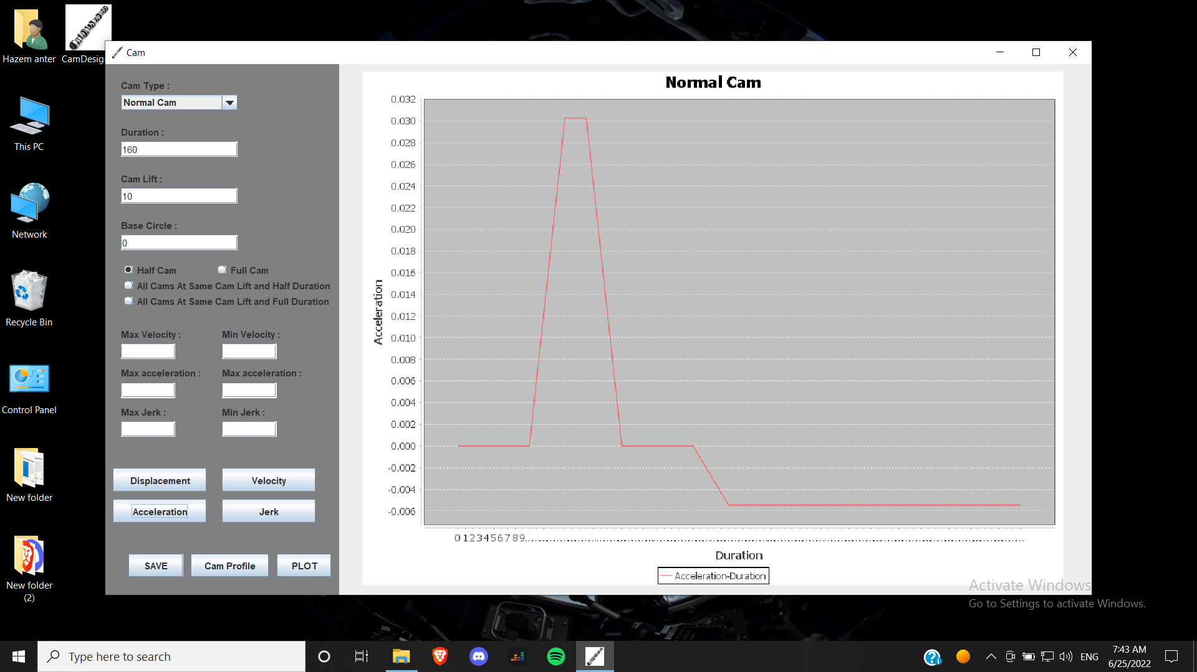

Acceleration

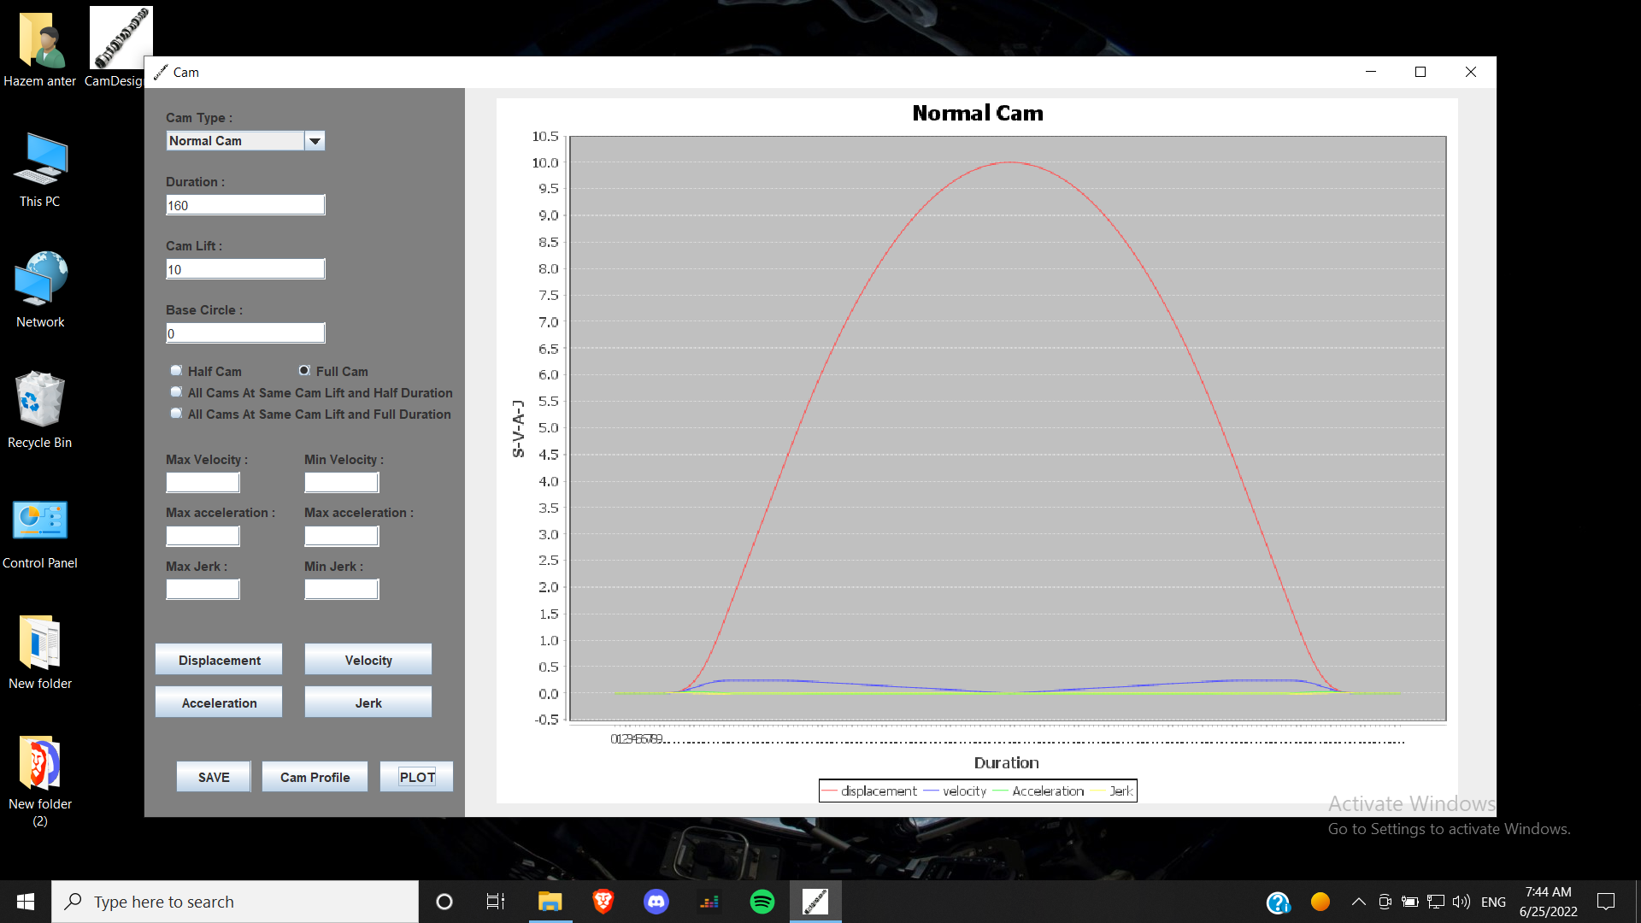

Full Cam

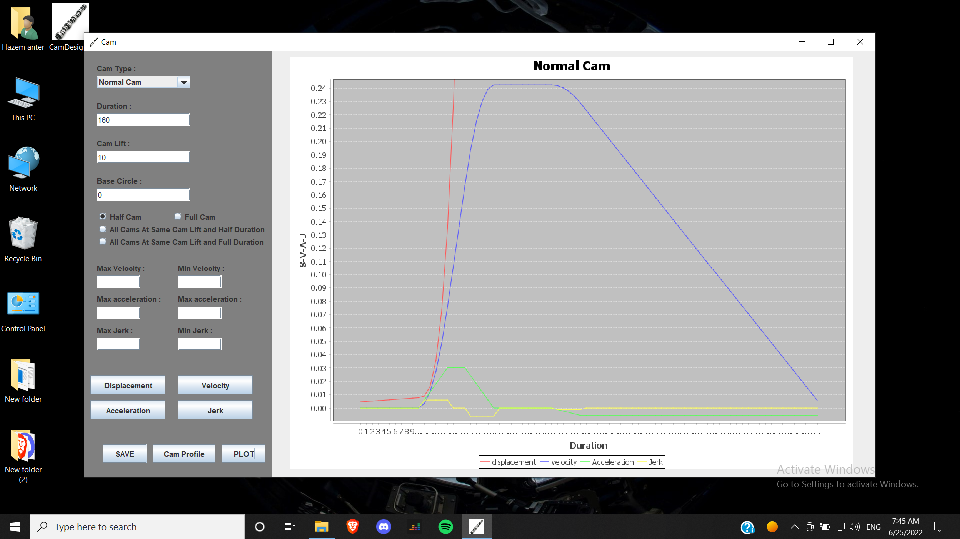

Compare ( v – a – j )

4.5. **Accurate Cam**

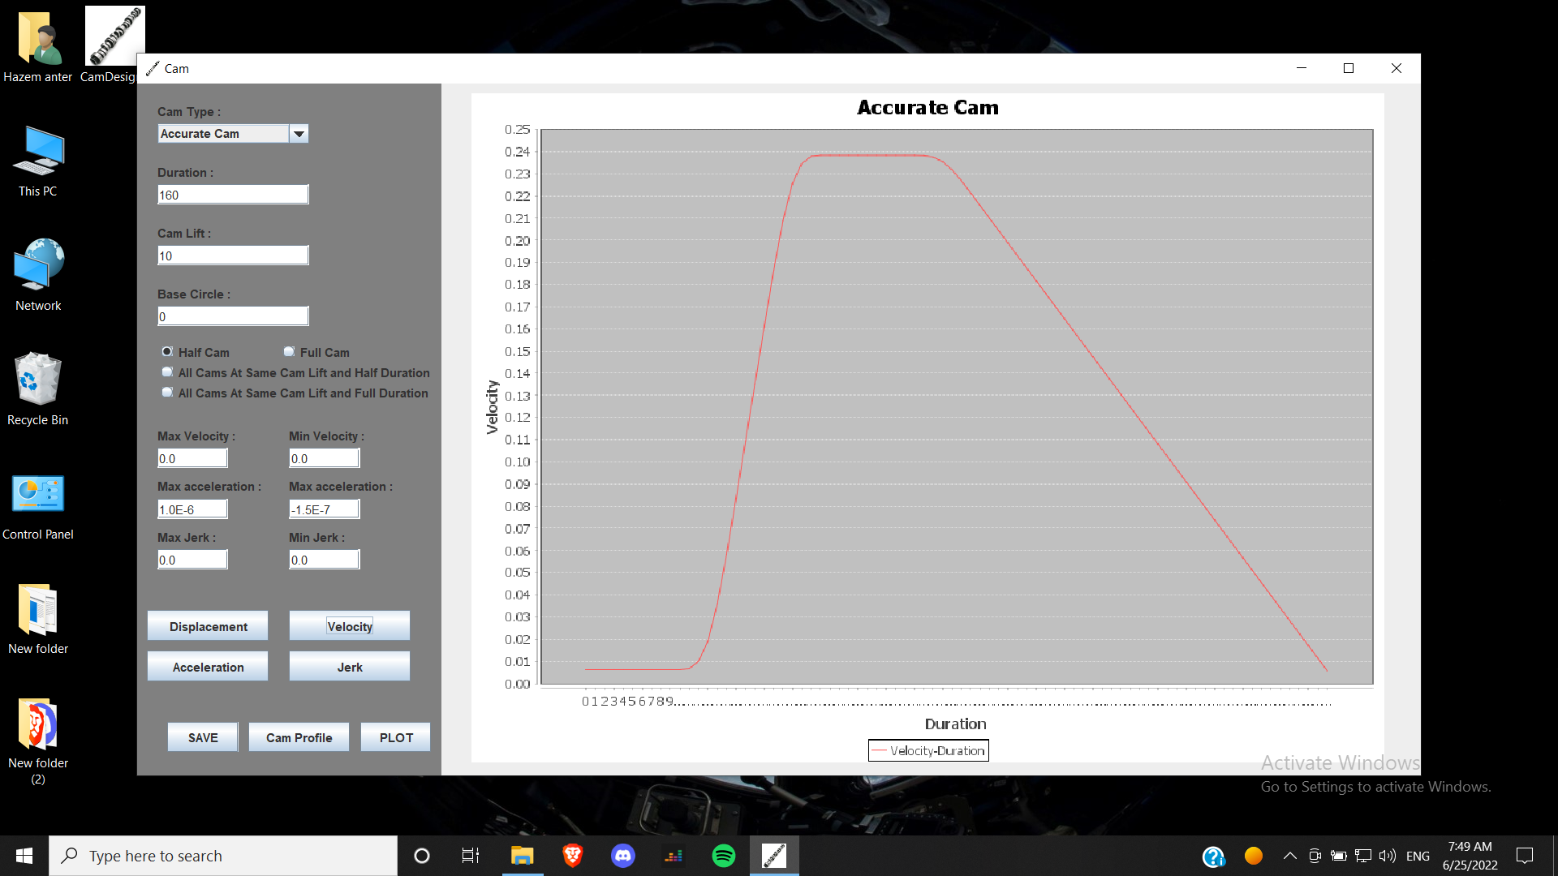

Velocity

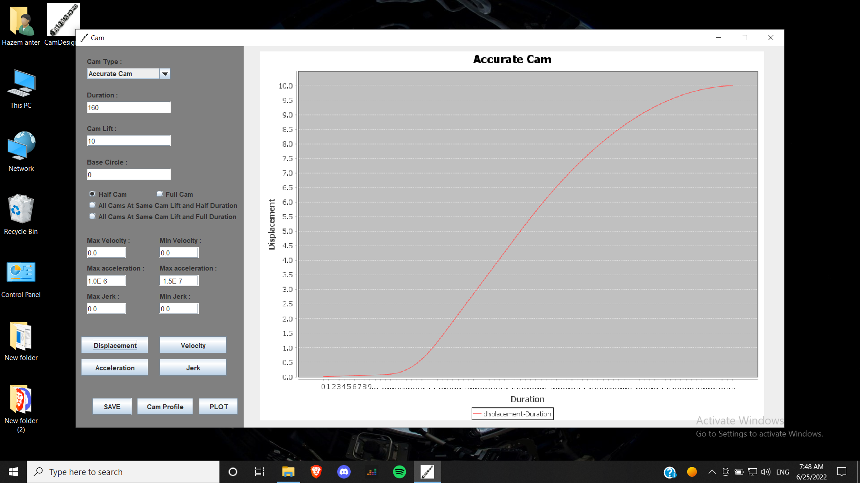

Displacement

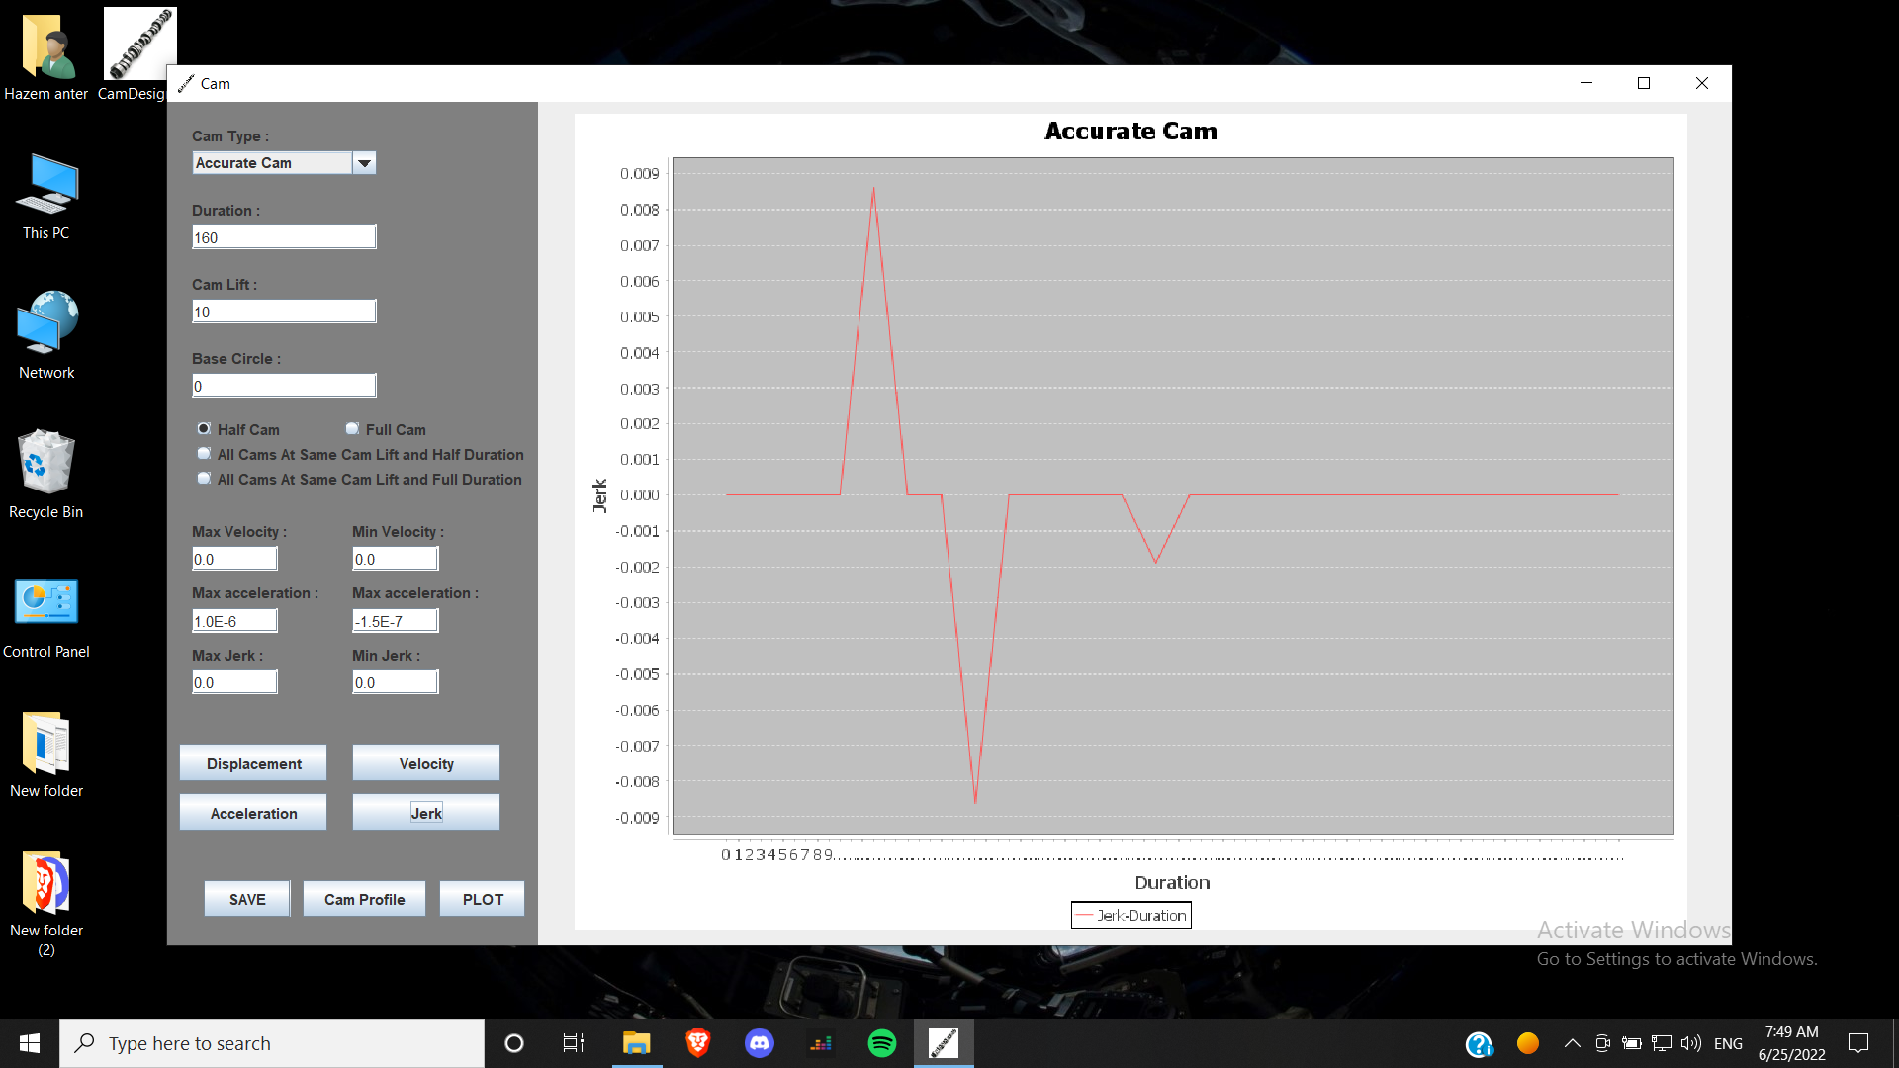

Jerk

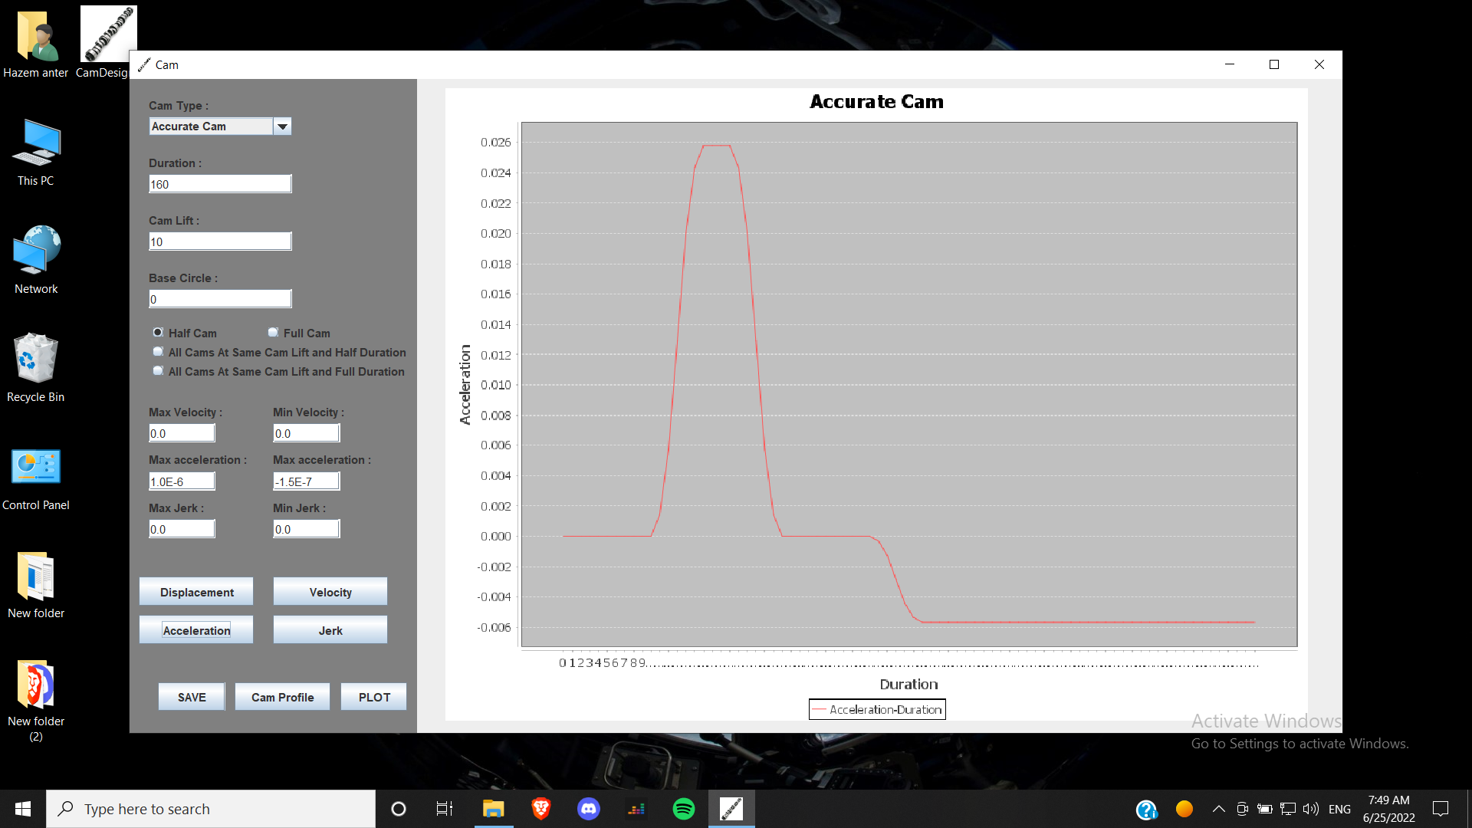

Acceleration

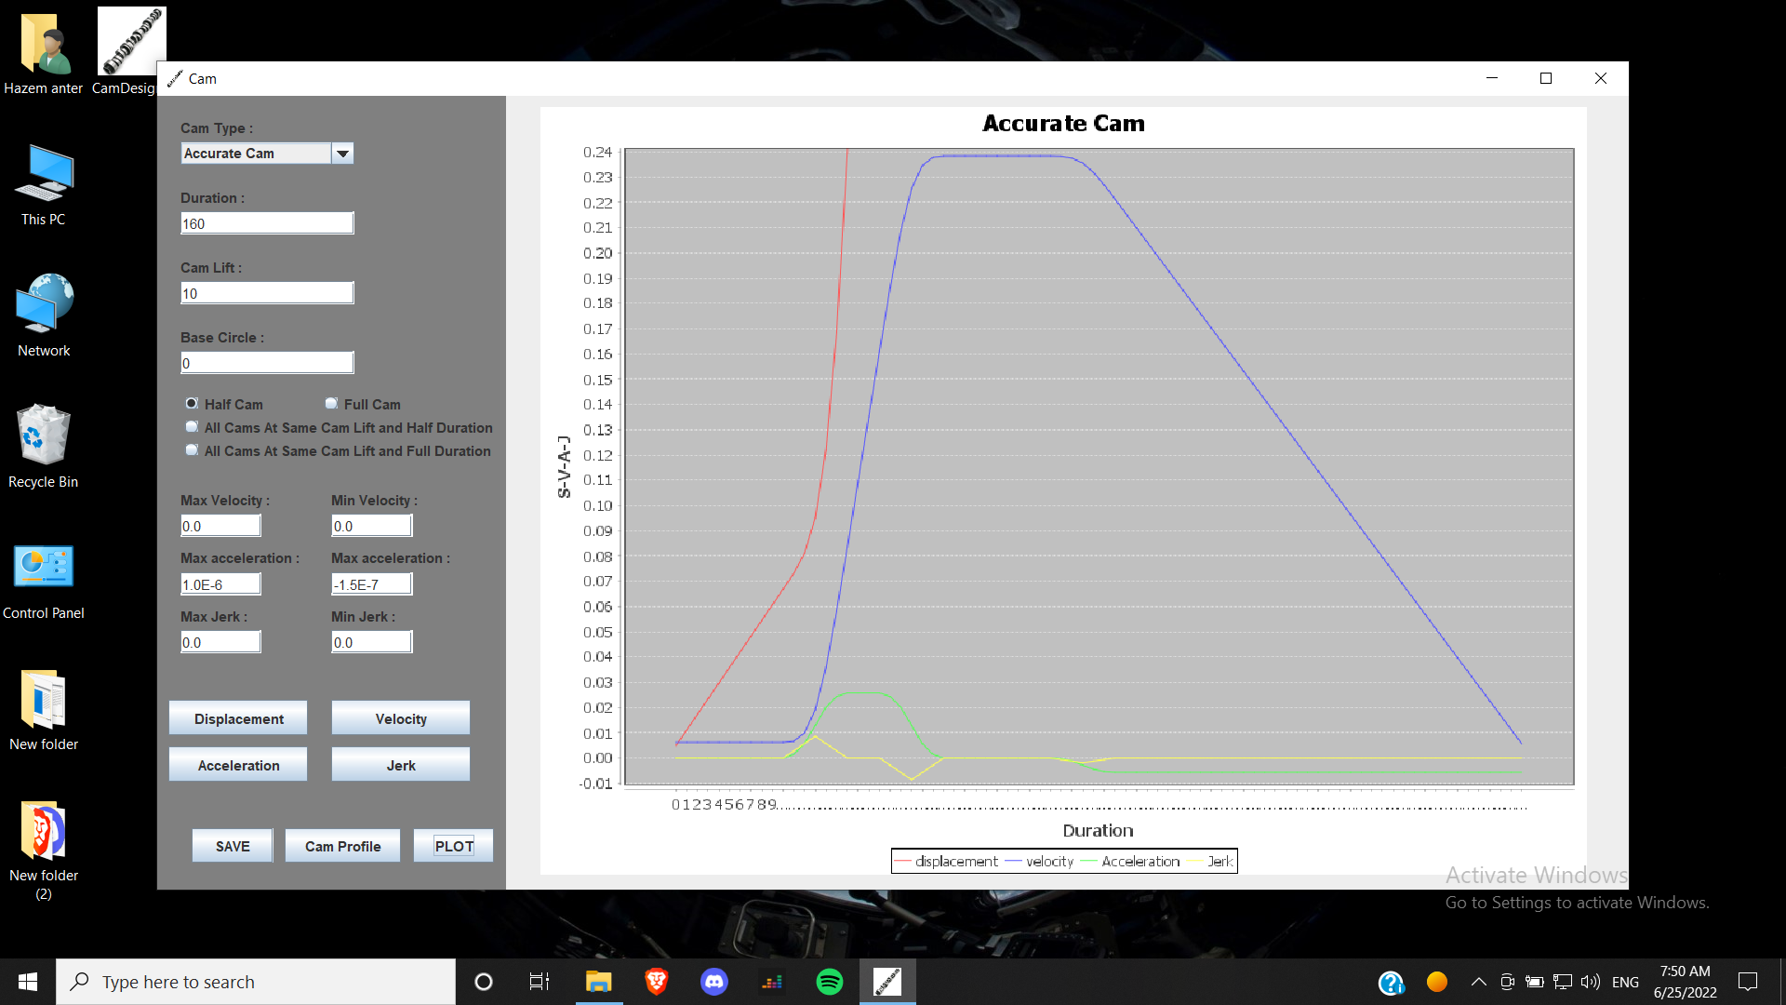

Compare ( v – a – j )

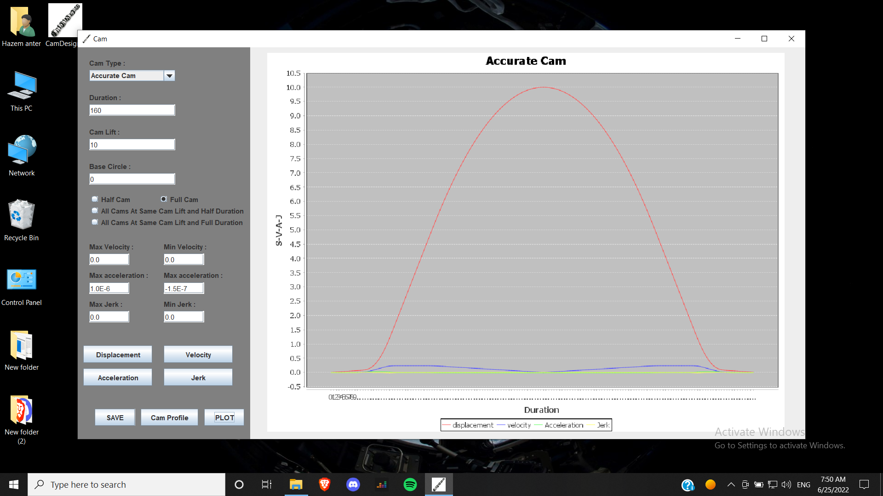

Full Cam

4.6. **More-Accurate Cam**

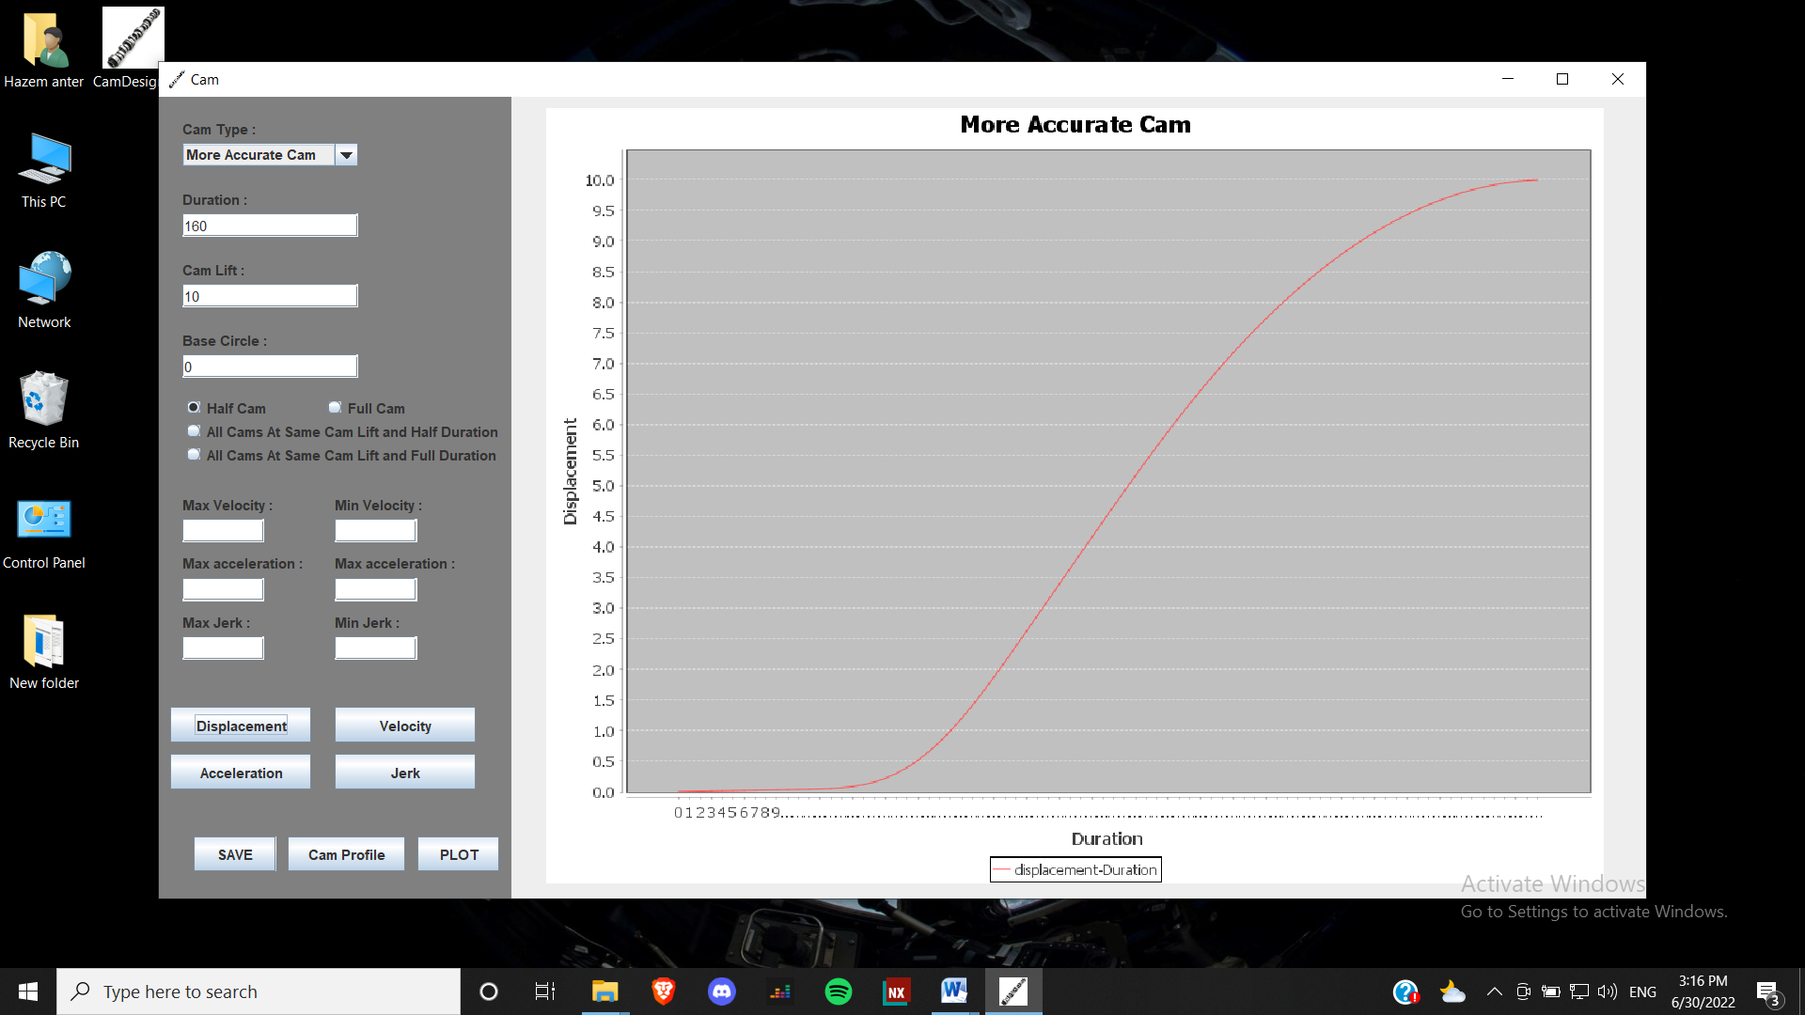

Displacement

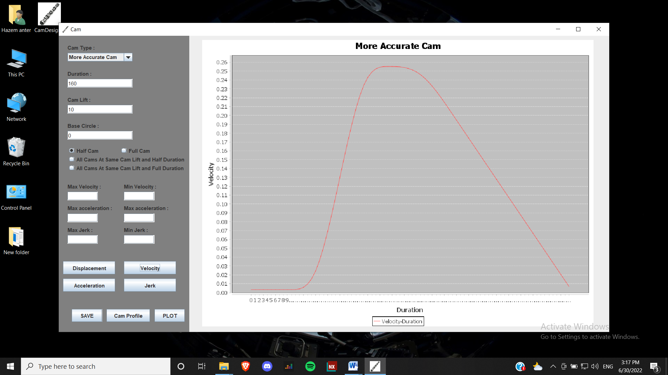

Velocity

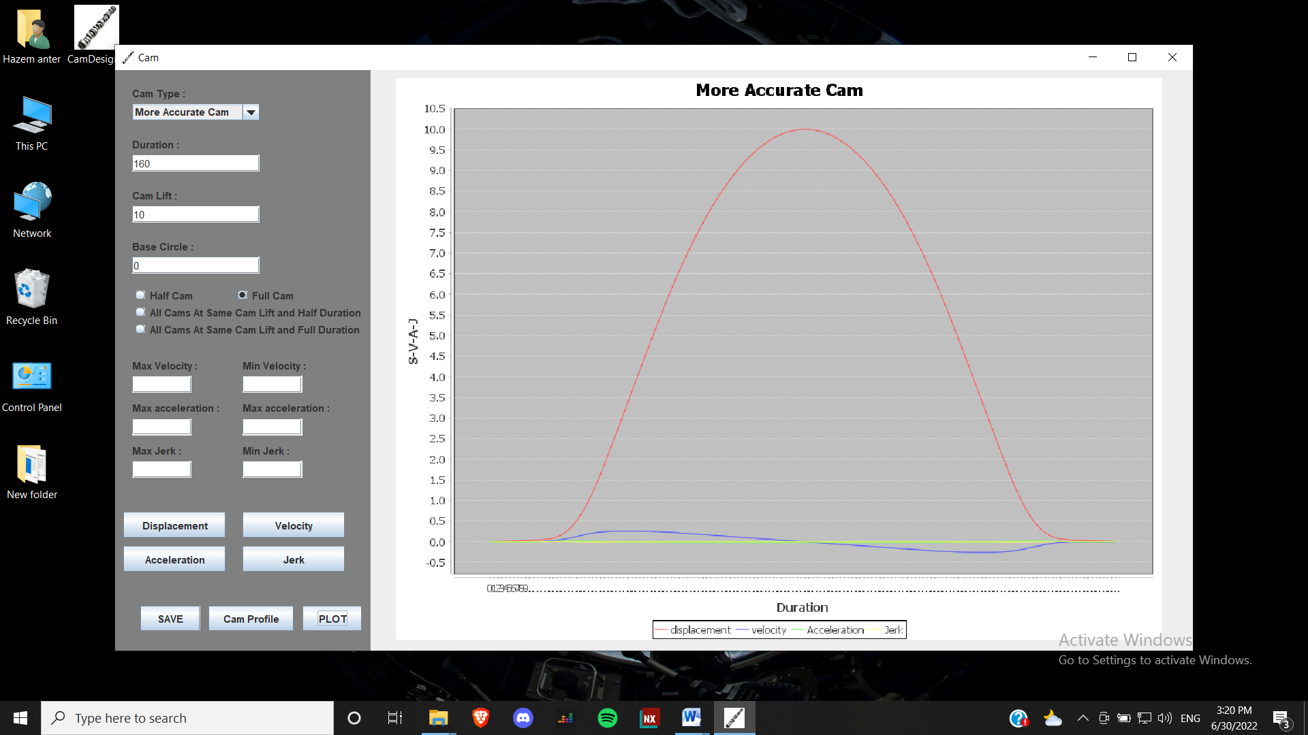

Full Cam

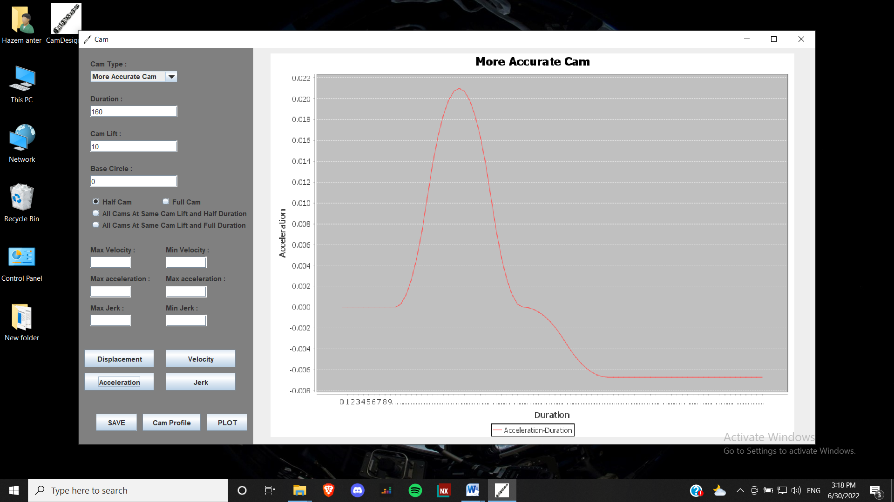

Acceleration

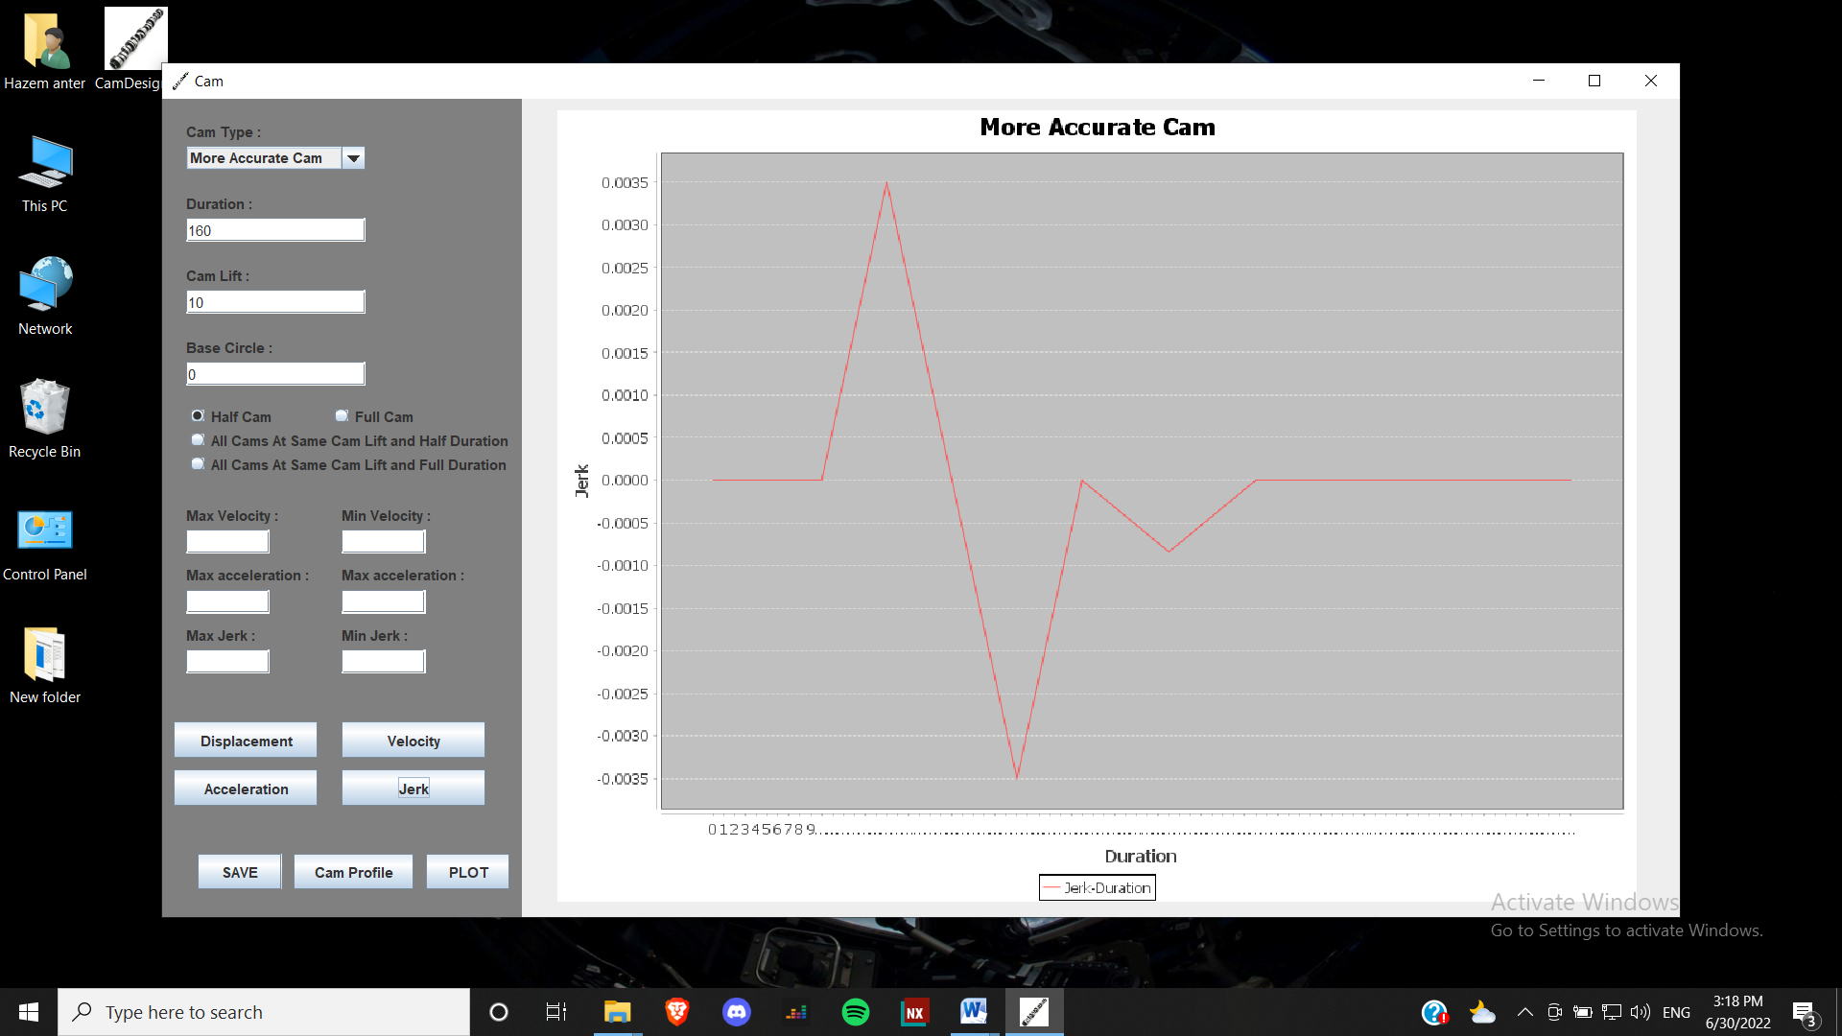

Jerk

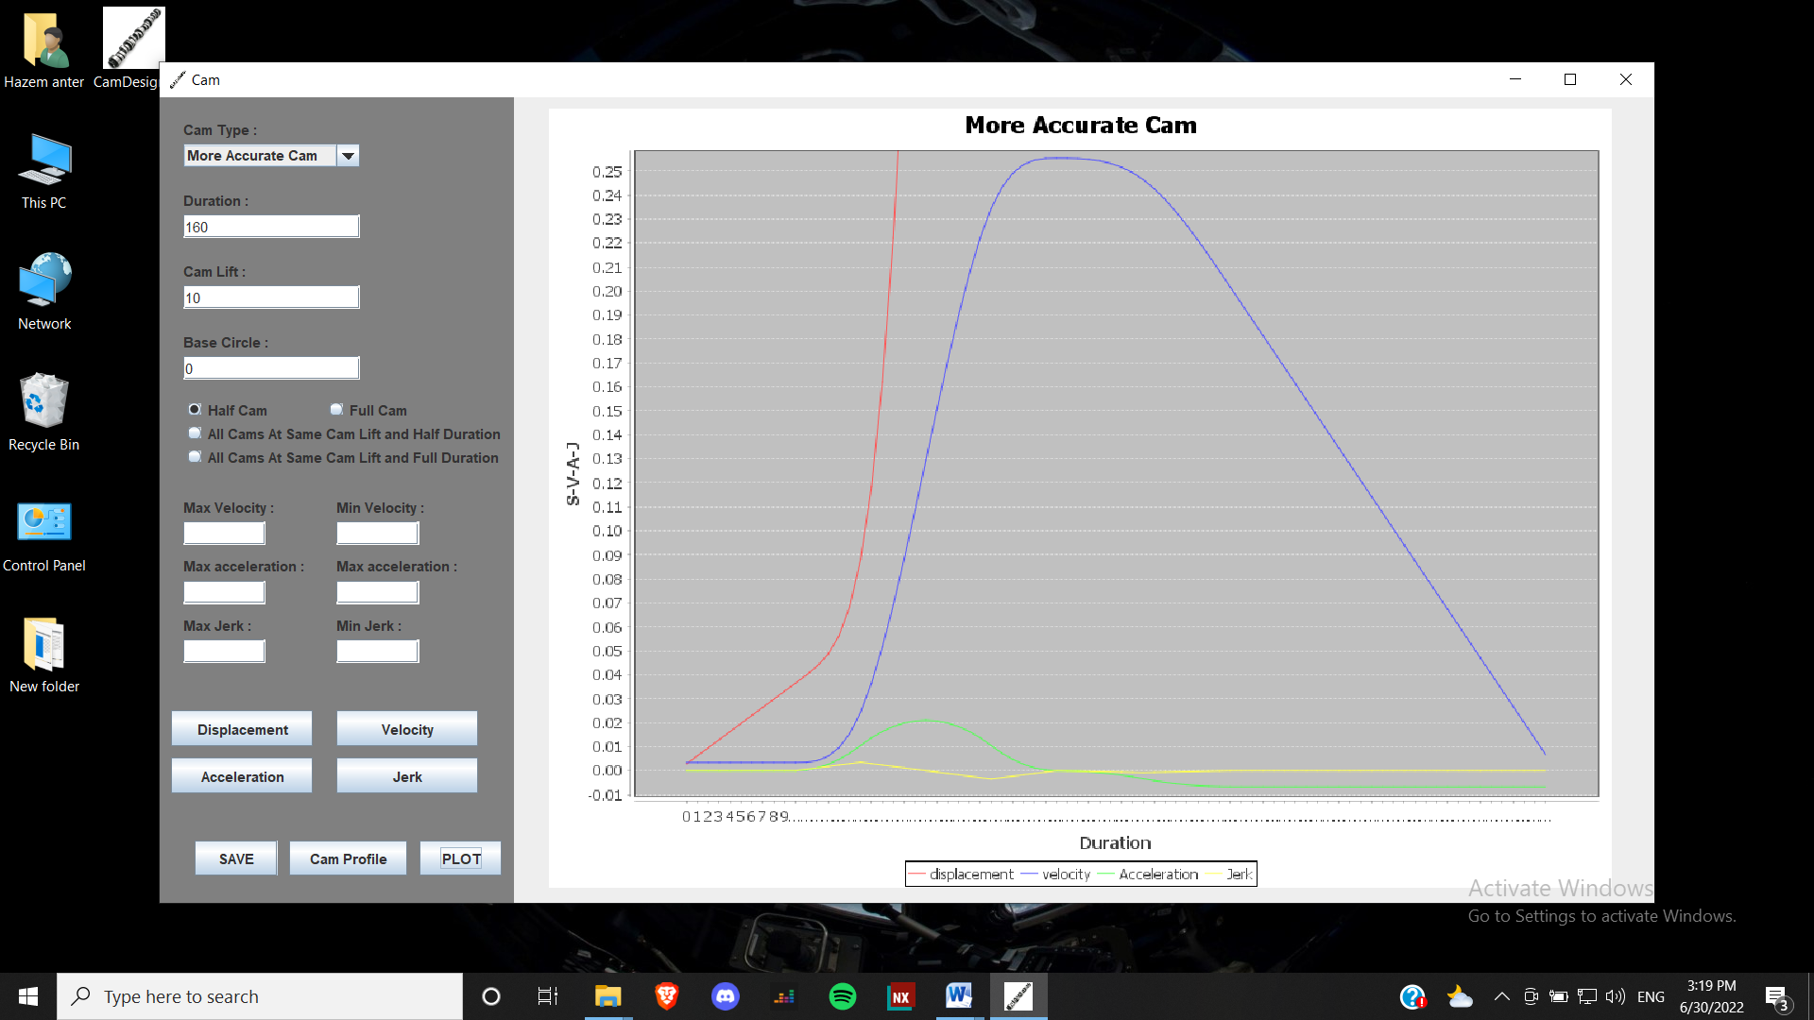

Compare ( v – a – j )

4.7. **Comparison Between The Four Cams**

**4.7.1. Displacement**

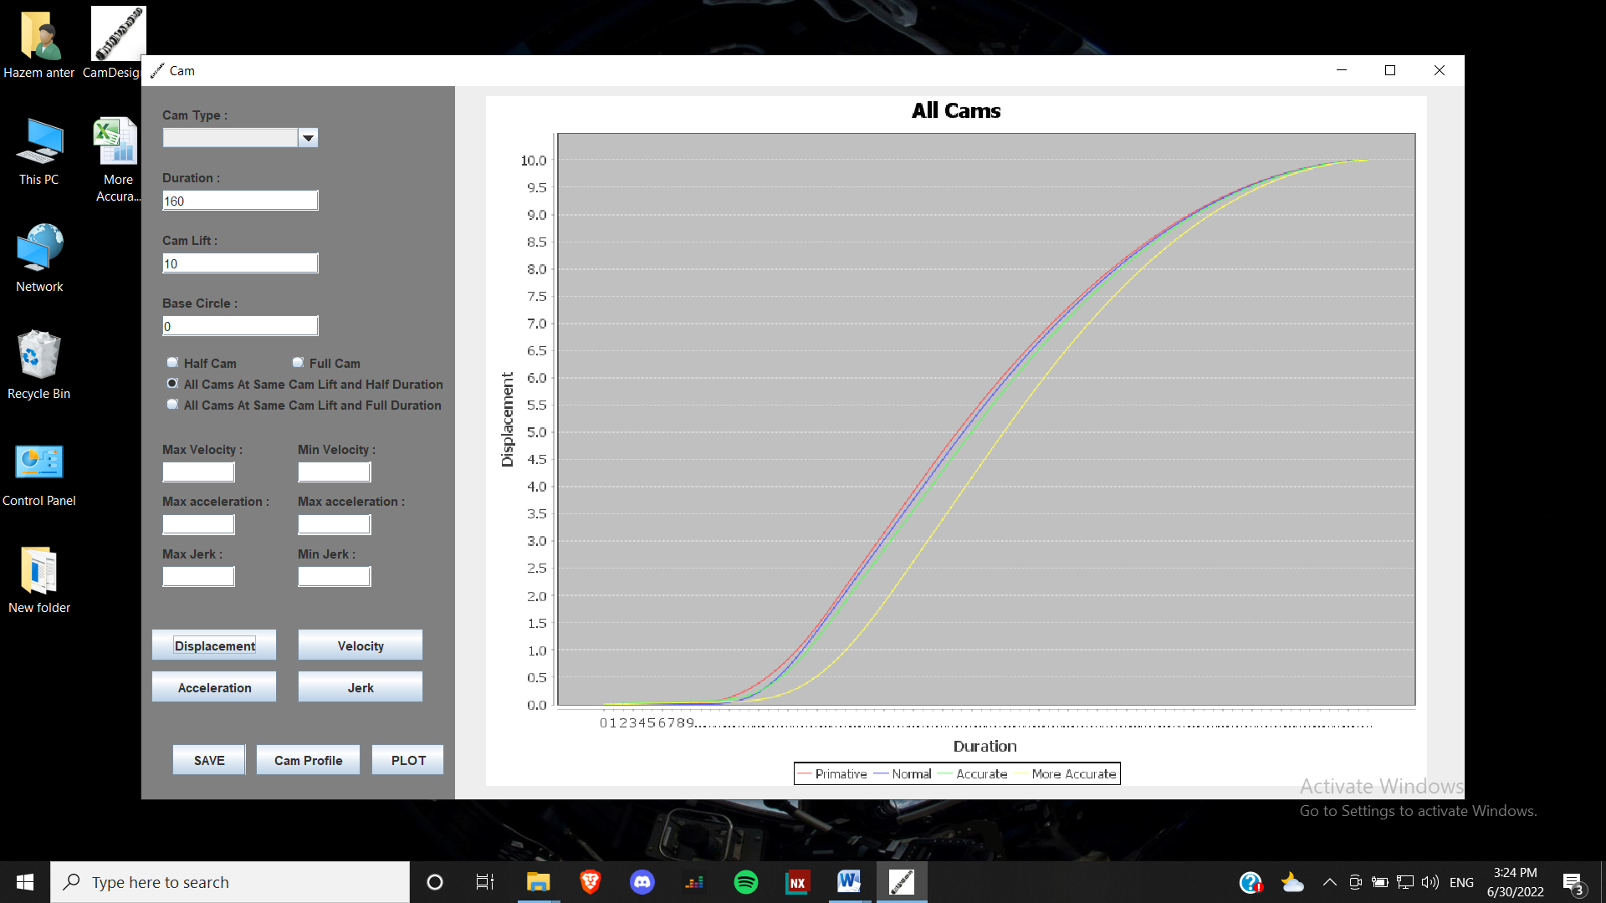

4.7.2. **Velocity**

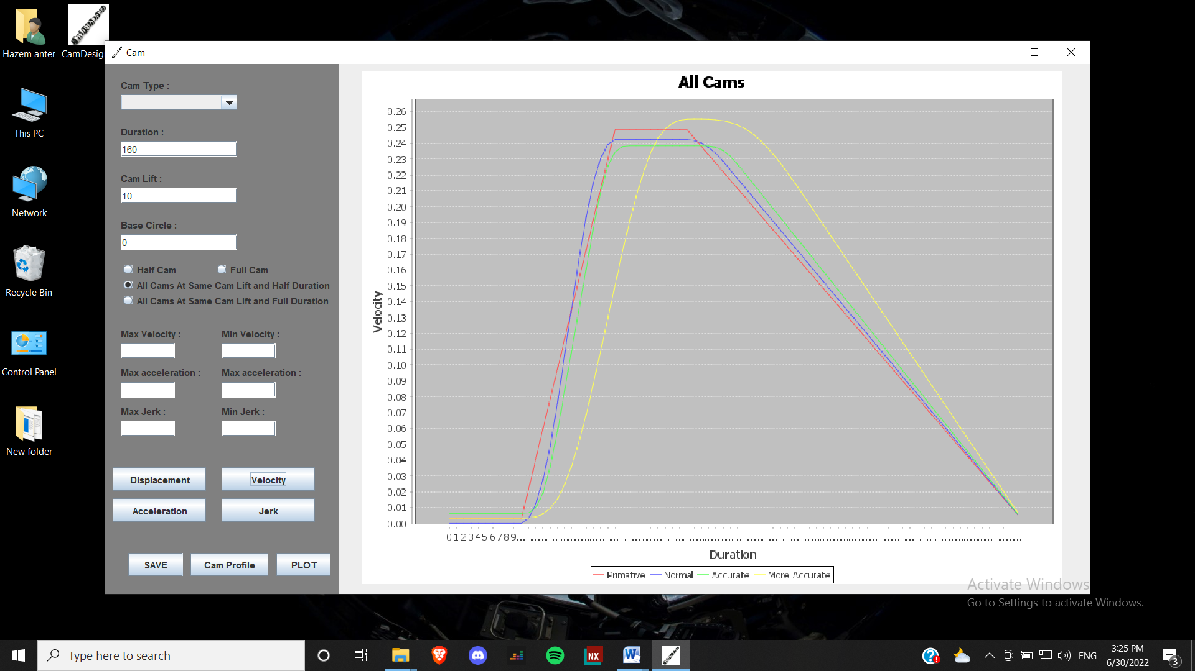

4.7.3. **Acceleration**

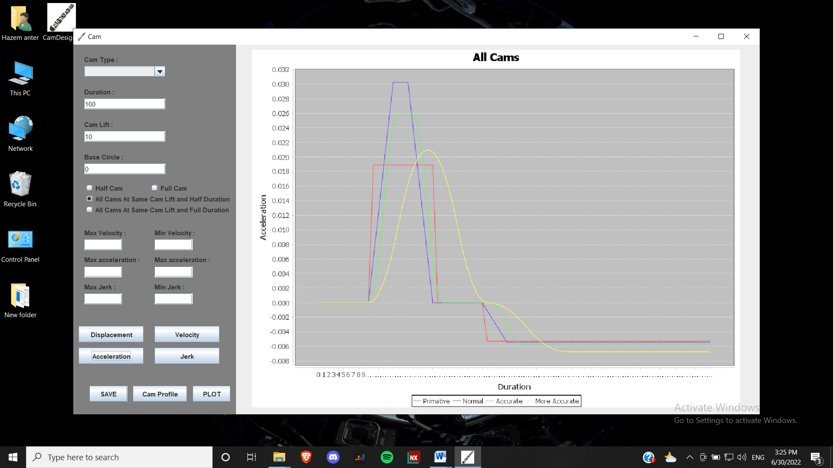

4.7.4. **Jerk**

